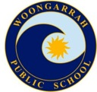**WOONGARRAH PUBLIC SCHOOL**

Friday 4 December 2020 NEWSLETTER Issue 21

**Semester two reports**

A huge thank you to our teachers and executive team who have been busy working on end of year reports.  Reports will go home on Wednesday 9 December.

**Presentation Day**

Our presentation day is planned for Wednesday 9 December. Students will attend various assemblies throughout the day to receive awards and celebrate the year of learning. This will be a student only event in 2020. This is consistent with all schools across Tuggerah Lakes network of schools, (with the exception of Wadalba Community school due to the size of the school hall) in order to adhere to existing Covid guidelines.

**Year 6 Farewell**



A Red-Carpet event has been planned for 9 December at Tuggerah Cinemas for Year 6 students and the Year 6 teachers. Mrs Dempsey has sent information home to all families with details.

**Covid-19 updates**

Principals were sent an email this week with draft planning guidelines to support us in planning for Term 1, 2021 activities. The draft Term 1 guidelines will be updated in line with NSW Health advice in January and I will be provided with the final approved guidelines before the start of Term 1, 2021.

Similarly, the Premier recently announced a further easing of restrictions in NSW. The Department is currently working to review these changes and update its guidelines. Schools will be kept up to date with any changes. I will communicate with you accordingly.

In the meantime, all current arrangements remain in place for non-essential visitors to schools, collection and pick up procedures and end of year functions and events.

**Before and After School Care**

A huge thank you to all families who completed the recent surveys regarding demand for before and after school care. Watch this space for more news early in 2021.

**Kindergarten 2021**

Congratulations to everyone involved in welcoming 64 new students to Kindergarten for 2021. Families can expect letters with details about class allocations and Best Start assessments in coming days. We have extended the time required for Best Start assessments in order to meet all Covid requirements and as such, all Kindergarten students will begin school on Wednesday 3 February, instead of Tuesday as previously advised.

**Staffing**

At this stage, we are anticipating 17 classes across K-6. Please contact me as soon as possible if you are aware of any family movements that may affect our class structure next year as this can have a huge impact on class organisation. We are planning for:

Early Stage 1 x 3 classes - Mrs Guest / Mrs Kelly; Ms Patterson; Mrs Johnson

Stage 1 x 5 classes – Mr Mills, Mr Smith / Mrs Rawson, Mrs Hindson, Mrs Ruskin, Mrs Ella

Stage 2 x 4.5 classes – Mr Demir, Mrs Hearne / Miss Baker, Mr Vrolyk, Ms Miller, Ms White

Stage 3 x 4.5 classes – Mr Demir, Mrs Black, Mrs Nicolas, Mrs Byrne, Mrs Le Loux / Mrs Khan

**Transition**

We offer an annual transition program for students who may require extra support in preparing for the new school year. These students will receive a social story and visits to their next year’s classroom and teacher in the remaining days. Thank you to Mrs Buhr as the DP / Learning Support Team coordinator for this important piece of work to support our students.

**School Development Days (SDD) dates for 2021**

Dates have been scheduled with the Department releasing the following dates:

* SDD Term 1 = 27 and 28 January.
* Years 1-6 students return Friday 29 January.
* Kindy start Wednesday 3 February.
* SDD Term 2 = 19 April. Students return 20 April.
* SDD Term 3 = 12 July. Students return 13 July.
* SDD Term 4 = 17 December. Students finish 16 December.

Your support of these days is greatly appreciated as they provide opportunity for staff to engage in high quality professional learning.

**2021 Ministers**

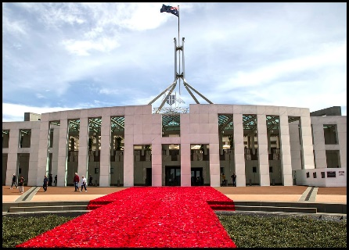Last Friday, 20 Year 5 students confidently gave their speeches for a position on the 2021 Minister team. They are to be congratulated for their efforts in front of their Year 5 peers, the 2020 Parliament and their teachers.

The new Ministers for 2021 are Cooper R, Sarah P, Lucy B, Ellie F, Brayden E, Isabella V, London N and Ella V.

Our new Ministers gave a speech via zoom to all of 3-6 today to determine who will be our Prime Minister and Deputy Prime Minister for 2021. The Ministers will find out their positions next Wednesday at Presentation Day. Congratulations to all our 2021 Ministers on their speeches today.

**Scripture and ethics**

Scripture has finished for the year and will recommence in February 2021. I have had a request from our Scripture Co-ordinators that they are looking for volunteers to teach Scripture in 2021. If you are interested in offering your services to teach Protestant or Catholic Scripture in 2021 on a Thursday, please contact Sharon Buhr and she can put you in contact with the Scripture Coordinators.

We have been very fortunate to have an Ethics teacher for Stage 1 and Stage 2 in 2020. Unfortunately, due to personal circumstances in 2021, our ethics teacher is no longer able to teach ethics classes. If you would be interested in volunteering your time to teach Ethics on a Thursday for about an hour, after training is completed, please contact Sharon Buhr and she can give you the Ethics Coordinators details.

**Home Reading**

Home Reading has now finished for the year, so please return all Home Readers so they can be checked and be ready for 2021. The online PM readers are still available if parents would like to continue Home Reading. Student logins and passwords were put on Google Classrooms.

**MESSAGE STICK**

On Thursday 26 November, students from Warnervale PS visited Woongarrah PS to deliver the Ngara Message Stick. Woongarrah Public School students did a welcome dance and joined the Warnervale students for a traditional smoking ceremony. Then Warnervale students presented the Ngara Message stick to our school leaders.

An Aboriginal Message Stick is a form of communication traditionally used by Indigenous Australians. It is usually a solid piece of wood, of varying length, etched with angular lines and dots. The patterns were used as a general reminder of the message. Traditionally, message sticks were passed between different clans and language groups to send messages. They were often used to invite neighbouring groups to corroborees, set-fights, and games. Message Sticks are often commonly called letters by Aboriginal people. They were transmitted by messengers, who could travel hundreds of kilometres to deliver them. The carrier of the message stick was granted safe passage across other Aboriginal nation’s lands.

The tradition of the message stick goes way back in Aboriginal culture and history and we, here on the land of the Darkinjung people, are lucky enough to bring this proud tradition back into current time as part of the Ngara AECG area initiative. Every year, the message stick will start at Kanwal Public School and travel to all of the schools in the Ngara AECG, as it slowly makes its way to Wyong High School and the Ngara Assembly of Excellence in Term 4, where it will be handed back to the Ngara AECG for safe keeping until they present it back to Kanwal to start another journey.

The message which is being passed on is about celebration, always moving forward and working together. The two animals on the front, the kangaroo and emu are representative of Australia and both animals never back down and always move forward. The dance icons and musical notes represent celebration and the concentric circles represent coming together and working as one.

On Wednesday 2 December, Mrs Guest, Sarah and Chelsea took the message stick to Wyong High School and presented the message stick to Wyong High students.

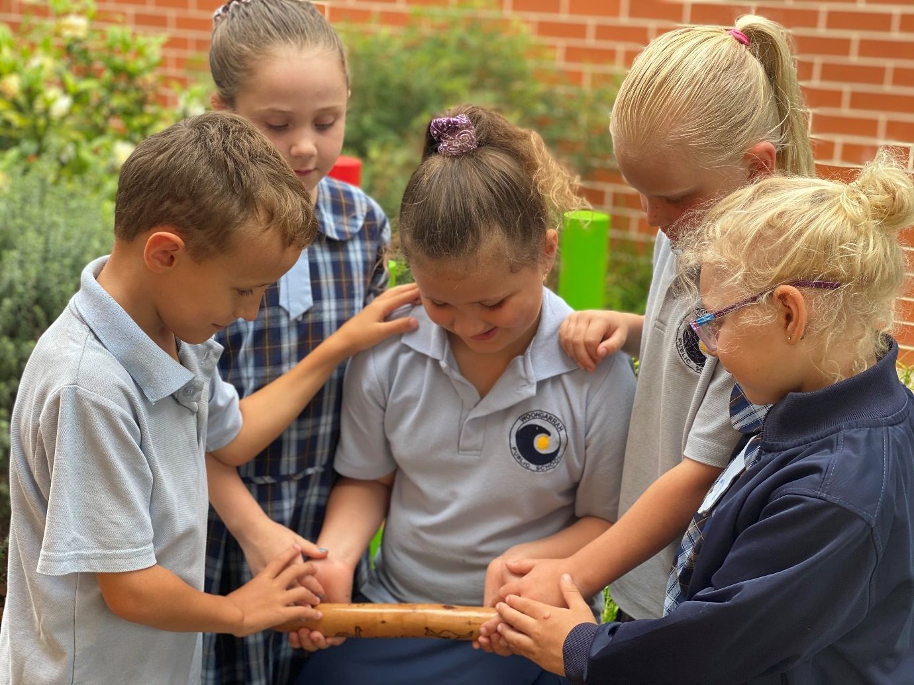

|  |  |  |  |
| --- | --- | --- | --- |
|  | **MERIT AWARDS** | **CAUGHT YOU BEING GOOD** | **QUALITY WORK** |
| HB1 | Alisha, Archawin, Annabella | Lilly | Cooper |
| HB2 | Sienna, Imogen, Sophia | Maisie | Ella |
| HB3 | Jade, Zoe | Cadence | Sienna |
| HB4 | Caleb, Charlie | Ava | Imogen |
| HB5 | Savannah, Aaliyah-Grace | Kathleen | Ethan |
| HB6 | Lily, Payton, Leon | Tyson | Emma |
| HB7 | Ivy, Hinewai, Violet | Keira | Haylee |
| HB9 | Georgia, Elliana | Jasmyn-Rose | Nakiah, Elliana |
| HB10 | Harry, Cooper, Mia-Rose | Jett | Lee |
| HB11 | Loghan, Ewan | Dawson | Elizabeth |
| HB12 | Jovi, KJ, Ruby | Tait | Tison |
| HB13 | Jaxon, Morgan, Tyler | Indy-Rose | Ethan |
| HB14 | Byron, Emilie | Blake | Leonor |
| HB15 | Beau, Lewis, Ethan | Riley | Evgenii |
| HB16 | Zac, Caleb, Soraya | Chelsea | Ayden |
| HB19 | Mikhail, Ruby, William | Ebonee, Rhys | Amelia |
| HB21 | Charlotte, Sarah, Izac | Ruby-Jane | Jordana |
| HB22 | Charbell, Kyah, Maddison | Cooper | Lucy |



Jasper HB11, Melody HB11, Lilly HB11,

Lily HB6, Leon HB6, Ebony HB13