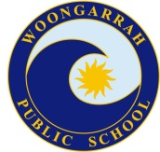**WOONGARRAH PUBLIC SCHOOL**

63-73 Mataram Road, WOONGARRAH NSW 2259

ph: 43927493 fax: 43927807

email: [woongarrah-p.school@det.nsw.edu.au](mailto:woongarrah-p.school@det.nsw.edu.au)

Website: [woongarrah-p.schools.nsw.gov.au](http://www.woongarrah-p.schools.nsw.edu.au)

The inclusive and caring school where expert staff support students to achieve excellence.

**KINDERGARTEN TERM 3 in REVIEW**

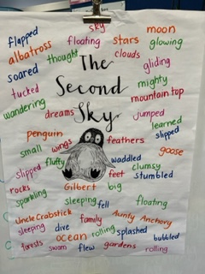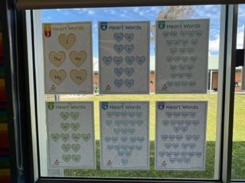In English, students have listened to quality texts eg The Hungry Caterpillar, Feathers For Phoebe, Wombat Stew and The Second Sky discussed them. They have been learning the letters and sounds, heart sight words and reading decodable and/or levelled texts. In Writing they have been learning how to write sight words, use the word wall to find sight words, stretch words to hear the sounds and locate the letters in them. Students have learnt about nouns, verbs and adjectives and increasing their vocabulary.

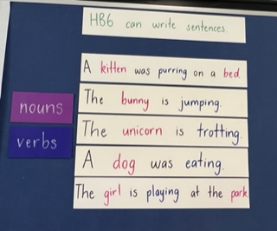

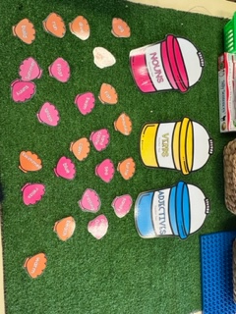

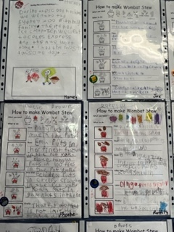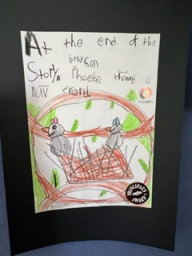

In Mathematics, students have been learning about numbers (reading, writing, making numbers), adding counters and numbers together, taking counters and numbers away, making equal/unequal groups, sharing objects, making patterns, finding 3D objects and 2D shapes, learning about day/night, o’clock time, learning about short/long, tall/short, heavy/light, making simple data collection and picture graphs.

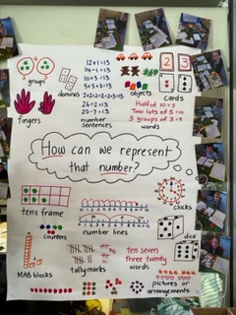 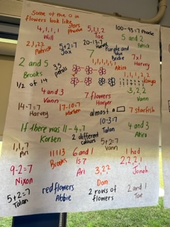 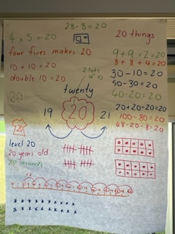

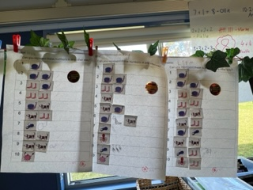 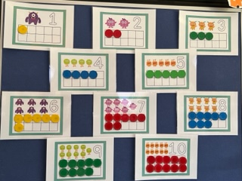

Artwork adorns the walls based on the letters/sounds students have been learning, or books they have been reading.

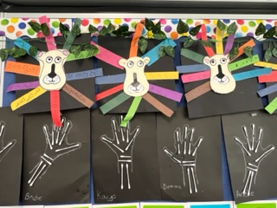 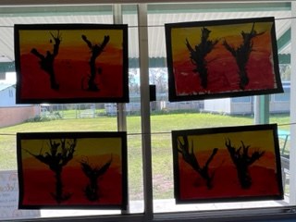

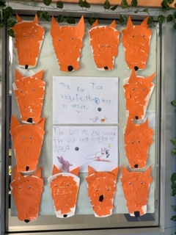 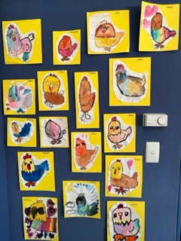 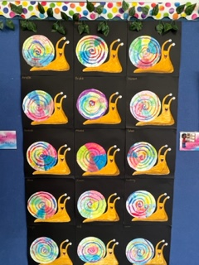

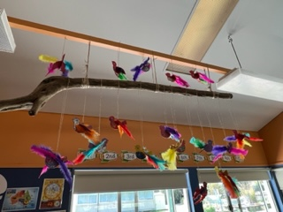 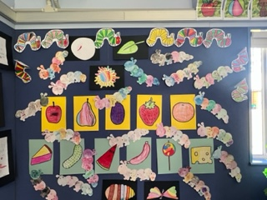

This term, students have studied History and explored different types of families, their own family history and they looked at artefacts and what artefacts tell us about the past.

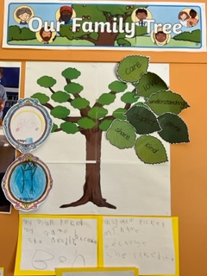 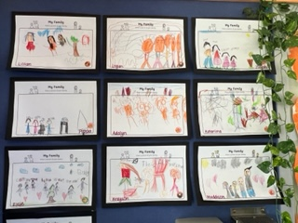

We are looking forward to Term 4, and the students last term of Kindergarten. It is amazing to see how much the students have learnt this year.

Mrs Buhr, Mrs Johnstone, Mrs Cranstone and Mrs Mileto

**STAGE 1 TERM 3 in REVIEW**

In English, the stage 1 students have completed author studies on Nick Bland (eg The Very Cranky Bear, Some Dads, Monster Chef) and Anthony Browne (eg, Piggybook, Zoo, Voices In The Park, The Tunnel and Into The Forest). The students made an emotional response to texts, identifying with characters and understanding figurative language, whilst identifying tone and mood. The students reflected on their own learning (while building a love of literature).

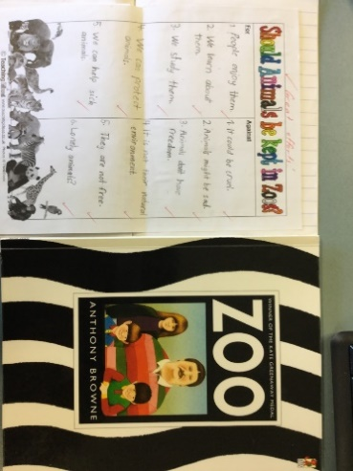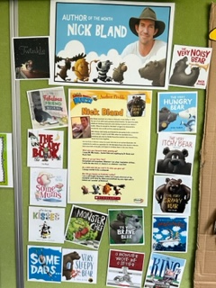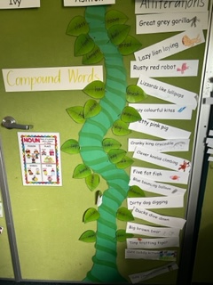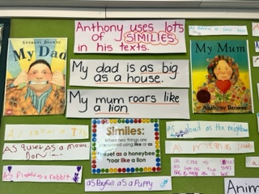

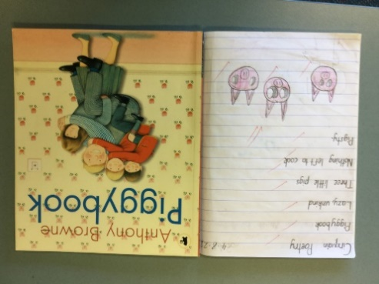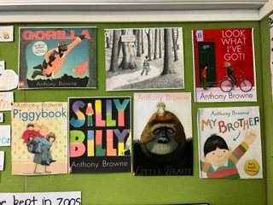

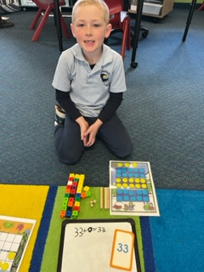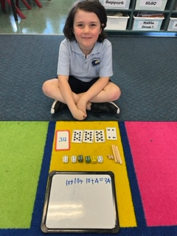In Mathematics, Year 1 students have been exploring different ways to represent numbers.

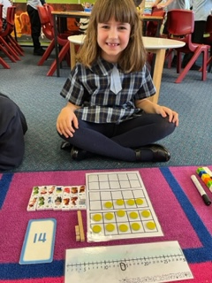

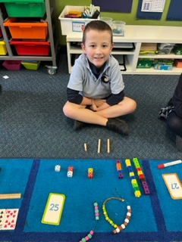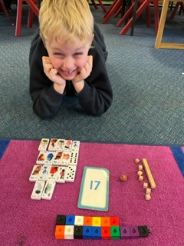

As part of their forming groups work in mathematics, Year 2 students participated in lessons focusing on developing an understanding of problem-solving using multiplication and division. The students have been busy using groups of objects to solve problems and doubling and halving strategies to solve written problems.

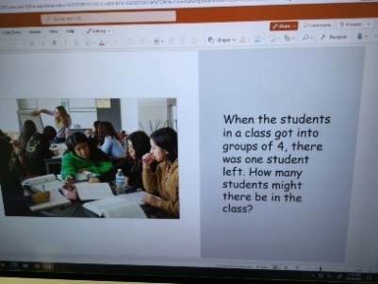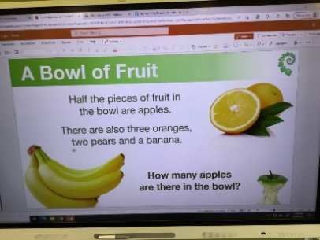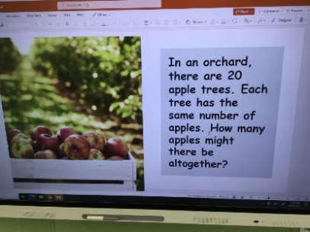

As part of the Strengths and Strategies For Safety PDHPE unit, Stage 1 students participated in lessons focusing on showing respect, being the same but different, my support network, my body is private and I can look after it myself, safe and unsafe touch, confusing touch, happy and unhappy secrets, bullying (What can I do about bullying?) and my strategies.

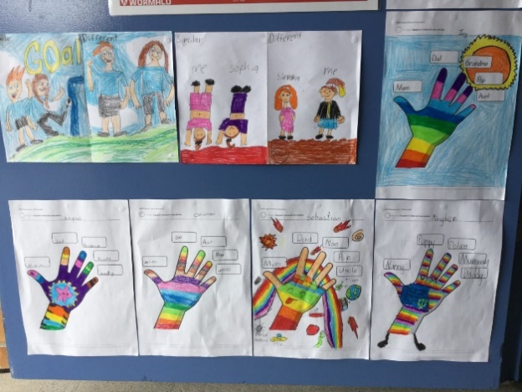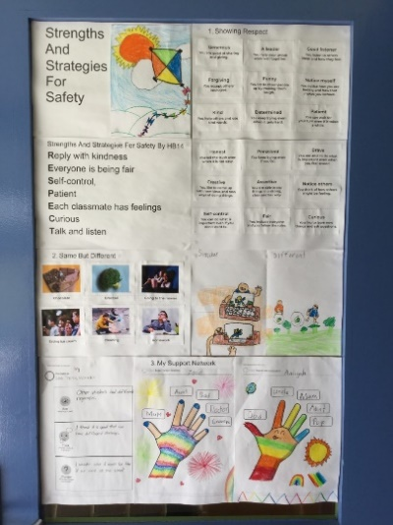 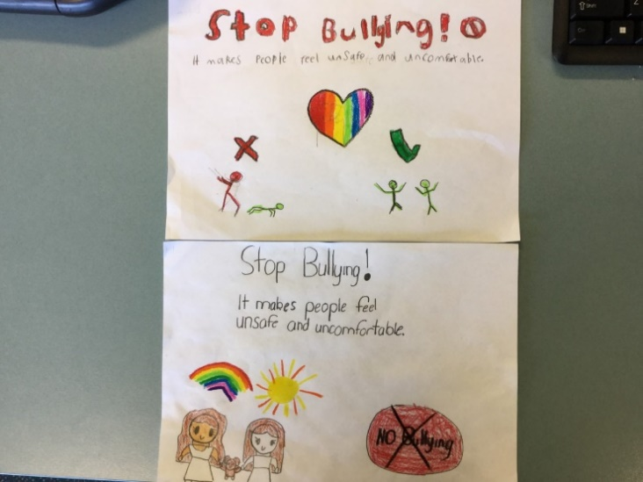

Students in Stage 1 have created some great pieces of artwork this term.

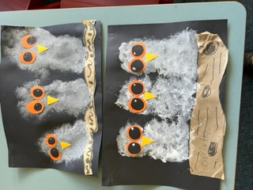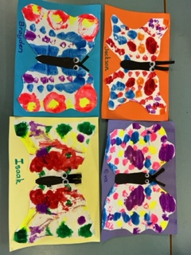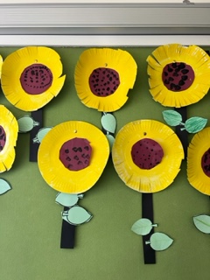

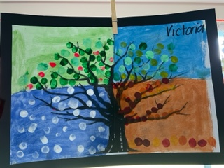 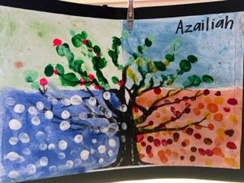 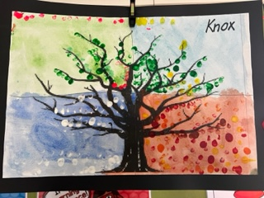

Students have loved using the new equipment during sport time and at lunch.

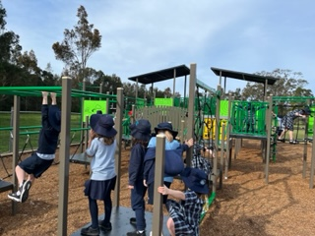 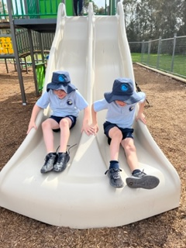

We are looking forward to another busy term in Term 4 including our rescheduled excursion.

Mr Smith, Mr Mills, Mrs Rawson, Mrs Guest and Mrs Ruskin.