WOONGARRAH PUBLIC SCHOOL

63-73 Mataram Road, WOONGARRAH NSW 2259
ph: 43927493 fax: 43927807
email: woongarrah-p.school@det.nsw.edu.au
Website: woongarrah-p.schools.nsw.gov.au

The inclusive and caring school where expert staff support students to achieve excellence.

Thursday 30 March NEWSLETTER Term 1 Week 10
Harmony Day
On Tuesday 21 March, we celebrated Harmony Day. Students completed activities in their classroom, attended a world expo and a special assembly. Thank you to the parents who attended and showcased their cultures. Students loved the hands on experiences and learning about different cultures. Thank you to Mrs Black and the Harmony day team for organising the day.
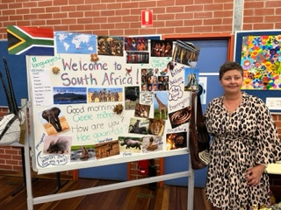
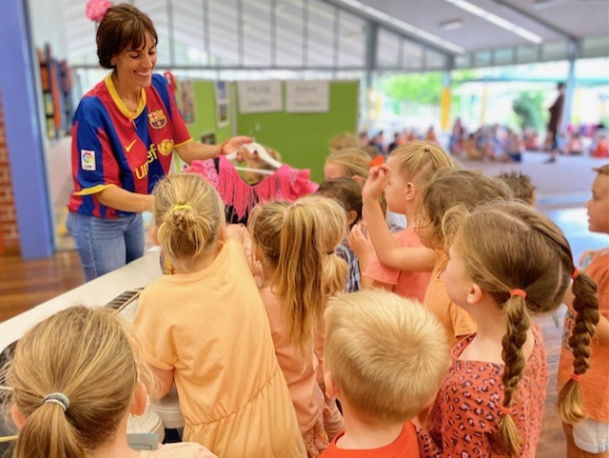
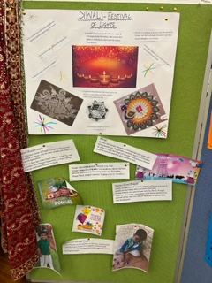
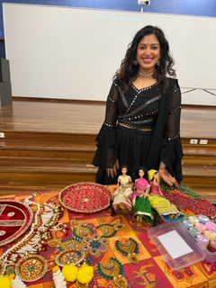
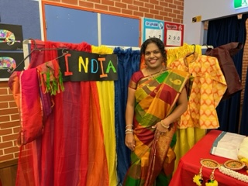
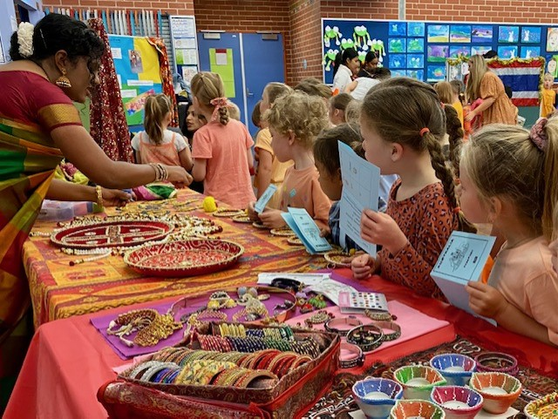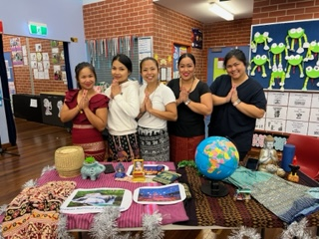

Extra curricula activities
As requested in the parent satisfaction survey, following is a list of extra-curricular events and the teachers that coordinate the activities:

Stage 3 boys dance group – Mrs Johnson
Stage 3 girls dance group – Mrs Black
Stage 2 dance group – Mrs Khan and Mrs McLean
Stage 1 dance group – Mrs Gillan
Years 3-6 choir – Mrs LeLoux
PSSA AFL (Girls & boys teams) – Mrs McLean
PSSA Soccer (Girls and boys teams) – Mrs Baker
PSSA Netball – Mrs McLean & Miss Foster
STEAM club – Ms Miller

All extra curricula activities including preparing sports teams for PSSA, Gala days and preparing dance groups are led by teachers that volunteer their time, often giving up lunch breaks for many weeks, and preparing costumes on weekends etc. On the days that these events occur, teachers give up learning time with their own class and may have to split classes which may affect the learning in other classes, so events can go ahead as there is no funding provided for these events to cover casual teachers. For these reasons we provide some events and try to cover a variety of sports etc but are limited to staff expertise and their willingness to volunteer.

Music Bus
The music bus comes to WPS on Wednesday and Thursday morning to provide music lessons to students, funded by parent. For more information about music bus see The Music Bus.
Easter Parade
On Thursday 6th April at 2:15pm, Woongarrah Public School will host our
annual K-2 Easter Parade.

Students bring in from home a decorated, Easter themed hat, mask, poster, or basket to parade with. Students are to wear school uniform.

ANZAC day march and service
Ms Miller will be leading a group of Woongarrah students for the ANZAC day march. Students to meet Ms Miller 10 minutes before the march commences wearing full school uniform. Details are as follows:

Anzac March
Address: Ron Alt Ln, Toukley NSW, Australia
View on Google Maps
Time: 9:45 am
Date: Tuesday 25 April
Information: March proceeds along Canton Beach Road into Main Road and past the Cenotaph then into Athol Street and ending at the Cenotaph.

School service
Ms Miller will lead the ANZAC day school service on Wednesday 26 April starting at 2pm.

Year 5 Opportunity Classes in 2024
Parents can now apply for their child to sit the Opportunity Class Placement Test for Year 5 in 2024 and the details are below. The tests will be held in designated high school test centres or at other facilities.
Key dates:
• Applications for Year 5 entry to opportunity classes in 2024 open on Thursday 30 March 2023 and close on Monday 15 May 2023 at https://education.nsw.gov.au/oc.
• All candidates are required to sit the Opportunity Class Placement Test on Thursday 27 July 2023.
Further information can be found in the attachment.
Calendar Events
29 March and 5 April – Parent/Teacher Interviews
6 April – K-2 Easter Parade

Term 2 Dates
24 April – Staff Development Day
25 April – ANZAC Day holiday
26 April – Students return.
26 April – 1:45 – School’s ANZAC Day service
5 May – Choir rehearsal
9 May – Paul Kelly cup – AFL
12 May – Cross Country carnival
12 May – P & C Mother’s Day event
15-19 May – Wellbeing week
17 May – Stage 1 Reptile Park Excursion
19 May – SRC Sports mufti to raise money for Stewart House
26 May – Sorry Day – 3-6 Assembly
29 May – 2 June – Reconciliation week
31 May- Stage 3 excursion
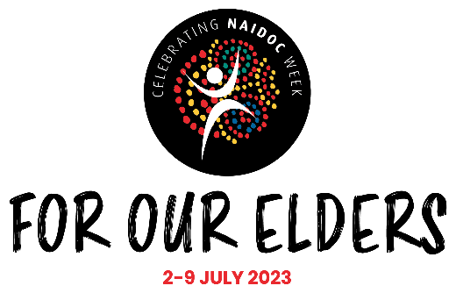
2 June – Jump Rope for Heart Jump off.
5 and 19 June – Review meetings
12-16 June – Wellbeing week
14 June – K-2 responsible pets incursion
27 June – NAIDOC day – TBC

Term 3 Dates
17 July – Staff Development Day
18 July – Students return.
26 July – Choir rehearsal
27 July – Parent evening interrelate session.
28 June – SRC PJs mufti day to raise funds for the Smith Family
31 July – 4 August – Education Week
7-11 August – Wellbeing Week
9, 16 & 23 August – Interrelate
10 August – Touch Football Gala Day
18 August – Day against Bullying and Violence
4 September – K-6 School incursion – Saving Lil and Archie
4-8 September – Wellbeing Week
11-14 September – Book Fair
13 September - Book Parade
14 September – RUOK day
20-22 – Stage 3 GATS camp

Term 4 Dates
9 October – Students and staff return.
26 October – Choir performance
1 November – Kindergarten 2024 Teddy Bears Picnic
8, 15 & 22 – Kindergarten Orientation
17 November – SRC Crazy Socks Mufti raining funds for Ronald McDonald House
27 November – 1 December – Stage 3 Broken Bay camp
6 December – Presentation Day
13 December – Year 6 Farewell
15 December – last day students attend.
More information on these events will be sent out closer to the events.
More events to be added include a Stage 2 and Kindergarten excursion.

High Expectations
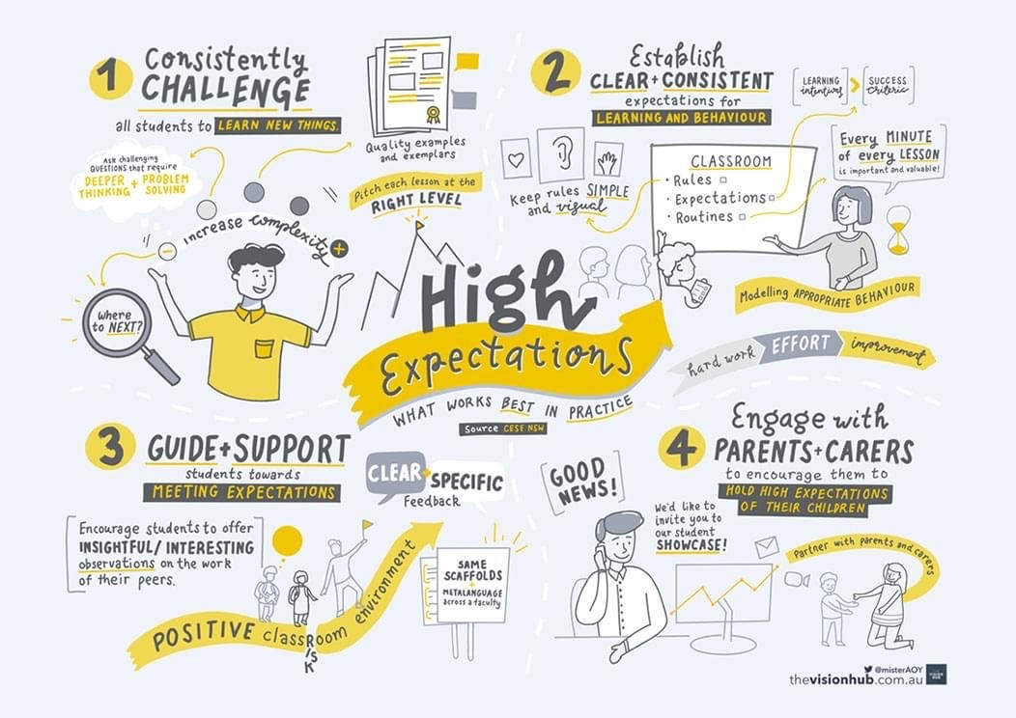
All staff have high expectations of our students. We strive to have a consistent approach to expectations for high academic achievement and good behaviour. Work is differentiated to cater for students’ abilities in the classroom so that all students are catered for. Special programs support students that require extra support. Adjustments are made to the classroom or playground environment to cater for students with disabilities and are documented in Individual Education Plans. Students that are high achievers are extended and supported. We look forward to engaging with parents at parent teacher interviews this week and next. The diagram below reflects how we implement high expectations.

Attendance
Students that have attendance of less than 80% have been identified and their attendance is being monitored. Parents will receive an email if we are concerned about your child’s attendance.
Our current attendance statistics are as follows:

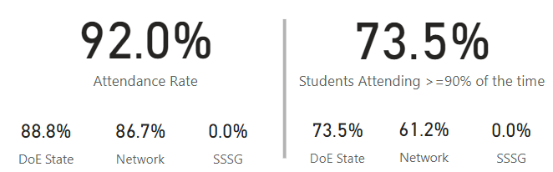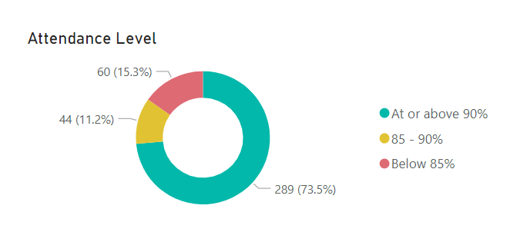

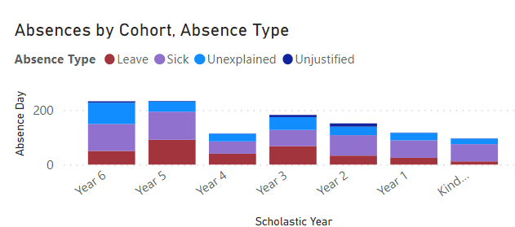

The current attendance rate per grade is:

Kindergarten – 94.5%
Year 1- 93.5%
Year 2 – 93.1%
Year 3 – 92%
Year 4 – 92.8%
Year 5 – 88.3%
Year 6 – 90.6%

Kindergarten is in the lead with 7 days of school to go. Which grade will have the best attendance for Term 1? If you would like more information please click on the link Compulsory school attendance (nsw.gov.au)

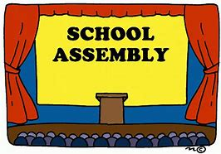
Assembly
Assemblies are on Friday starting at 2:15pm in the school hall. Visitors need to check-in via the QR code at the front gate or the iPad in the front office, sanitise and try to maintain physical distancing. It is wonderful to film your child’s performance at Assembly but please be reminded that these videos that contain other students should not be shared on social media as not all students have publishing permission.

Assembly Roster
Term 1
Week 10 – 3-6 Assembly | HB16 Hosting
Term 2
Week 2 - 3-6 Assembly | HB8 Hosting
Week 3 – K-2 Assembly | HB9 Hosting
Week 4 – 3-6 Assembly | HB4 Hosting
Week 5 - K-2 Assembly | HB11 Hosting
Week 6 - 3-6 Assembly | HB3 Hosting
Week 7 - K-2 Assembly | HB10 Hosting
Week 8 - 3-6 Assembly | HB2 Hosting
Week 9 - K-2 Assembly | HB5 Hosting
Week 10 – 3-6 Assembly | HB1 Hosting

Sharon Buhr
Relieving Principal

Sad Farewell
It is with mixed emotions that I share the news that Friday Term 2, Week 2 will be my last day at Woongarrah Public School. I was successful in gaining an Assistant Principal role at Kanwal Public School. This year marks my 8th year at Woongarrah and what a wonderful 8 years it has been. It has been an immense pleasure to work alongside Mrs Clarkson, Mrs Buhr, our incredible teachers, SLSOs and staff. I have always enjoyed working in partnership with parents to ensure there is a strong connection between home and school for students. The students will be told after this newsletter goes out that I am leaving. It’s going to be incredibly hard to say goodbye to them. I hope to be able to come and say hello from time to time. Thank you again for an unforgettable 8 years, Woongarrah Public School will always be a very special place for me.
Ms. Miller 😊

Jump Rope for Heart
Next term as part of our school sport program the students will be participating in Jump Rope for Heart. An email with further information will be sent shortly as well as a flyer sent home.
This program will run from weeks 1 - 5 on Fridays or their allocated sport day, with a jump off day organised in Week 6.

We look forward to participating in a wonderful event to not only raise money for a good cause but to also encourage our students to be physically active.

Mrs McLean - Jump rope for Heart coordinator

Cross country Carnival
This year’s cross country carnival will be held on Friday 12 May at Woongarrah Oval on Hakone Road, Woongarrah. Parents are most welcome to attend.
9.00 am – students come to school in their sports uniform or in house colours, go into class with their teacher, get their name marked off, go to the toilet, and get a drink. Students bring a backpack with their fruit break, recess and water. Students need to wear their school or sports hat and apply sunscreen.
9.30 am - students will come to the COLA with their teacher. Year 2 students that turn 8 this year and have completed a permission note will line up with Mrs McLean.
9.35 am – students and teachers will walk to the oval.
9.50 am – when everyone arrives at the oval and students will make their way to the house groups with the house captains.
10. 00 am – races will begin in the following order:
1 | 8- and 9-year-old boys (2 kms)
2 | 8- and 9-year-old girls (2 kms)
3 | 10-year-old boys (3 kms)
4 | 10-year-old girls (3 kms)
5 | 11-year-old boys (3 kms)
6 | 11-year-old girls (3 kms)
7 | 12- and 13-year-old boys (3 kms)
8 | 12- and 13-year-old girls (3 kms)

12.30 am – the end of the day and students will tidy up the oval and then walk back to school or let their teacher know they are leaving to go home with a parent and get their name marked off.
Mrs Lee and Mr Vrolyk - Cross Country Carnival Coordinators
2024 Year 7 Enrolments
If you haven’t already completed an Expression of Interest for Year 6 to Year 7 transition or completed an online Expression of Interest (EOI) can you, please do so before the end of term. The online process can be accessed through our website or clicking on the link below.
Moving to high school (nsw.gov.au)
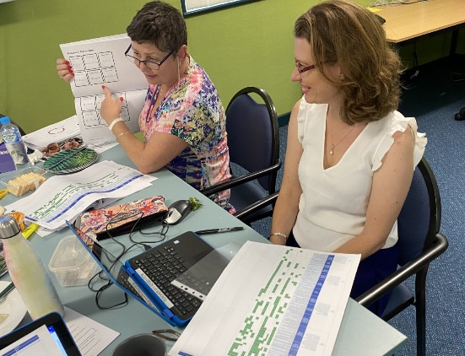
Curriculum Reform at WPS
The NSW Curriculum Reform is a program to deliver a new curriculum for Kindergarten to Year 12 from 2024. The new curriculum is being developed by the NSW Education Standards Authority (NESA) and aims to strengthen and streamline what is taught in schools. All primary school teachers will receive a guaranteed 5 hours per term in 2023.
Teachers at WPS have been engaging in Curriculum Reform professional learning over the last few weeks. All stage teams have been looking at planning for Term 2 units of work in English and mathematics with a focus on quality teaching, learning and assessing. The collaborative process has allowed teachers to have an in-depth knowledge of the new curriculum and designing quality differentiated assessment tasks to support student learning.

The K-2 Syllabus and Phonic Knowledge

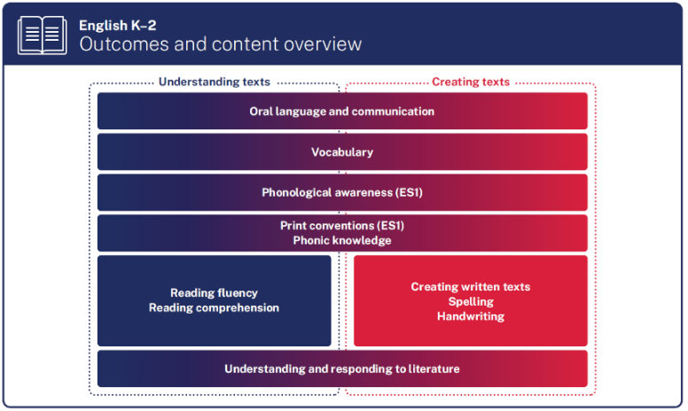
Phonics and early reading

Phonics is the relationship between printed letters (graphemes) and the sounds they represent (phonemes). Phonics instruction connects the phonemes with graphemes so that the reader can transfer knowledge of sounds to the printed word.

Students need to learn to blend phonemes and graphemes together to read words. The goal of phonics instruction is to help readers quickly determine the phonemes in unfamiliar written words. When readers encounter new words in texts, they use phonics skills to decode and understand.

How do we teach phonics in the early years at WPS?
We teach phonics using Little Learners Love Literacy® – a structured and explicit program. It is sequenced in seven stages to teach children the 44 sounds of the English language and the understanding that each speech sound (phoneme) can be represented by different groups of letters (graphemes). Please see the attached parent letter explaining the Little Learners Love Literacy program which also offers some helpful hints for supporting phonics at home.

HB11 students are learning about /ch/- lunch, chicken and chips. | HB9 students are making rhyming words. | HB10 students are listening for vowel sounds and matching it to the correct grapheme
HB12 students are writing words with the short /o/ sound. | HB14 students are reading decodable books. | HB13 students are reading a decodable book.

Harmony Day
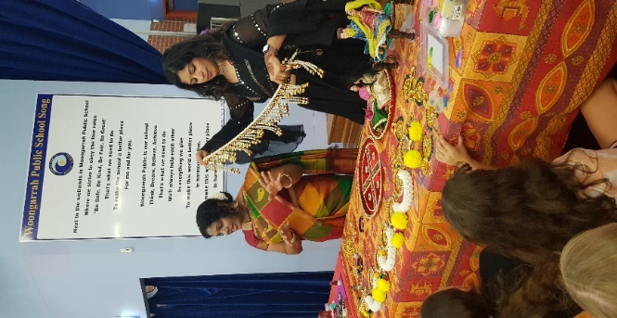
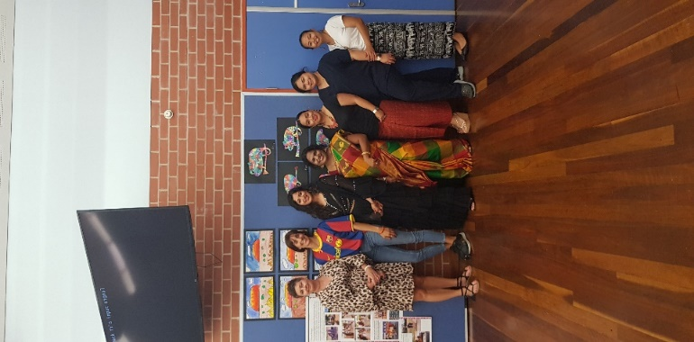
On Tuesday 21st March, the students, staff and community at Woongarrah Public School celebrated the diversity of our community with a World Expo and whole school assembly celebration. Students were encouraged to wear orange or cultural dress, and visited the “countries” of South Africa, Thailand, Spain and India. They were fortunate to learn about language, traditions, customs, food and celebrations, and we would like to thank our wonderful parent volunteers who so kindly gave up their time for the day. During our assembly we learned about the history of Harmony Day and the many stories and cultures that make our school community so great! Thank you to everyone involved in helping to make this day so special!
Mrs Black
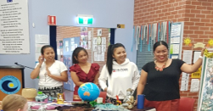
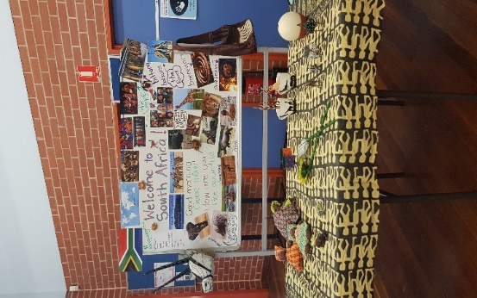

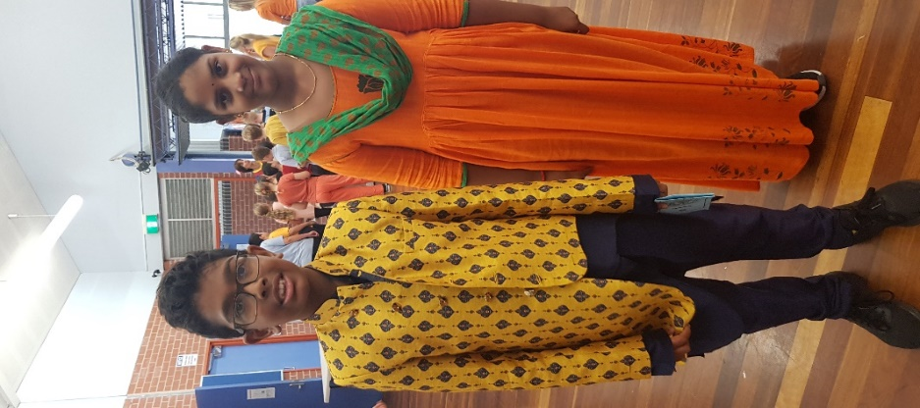

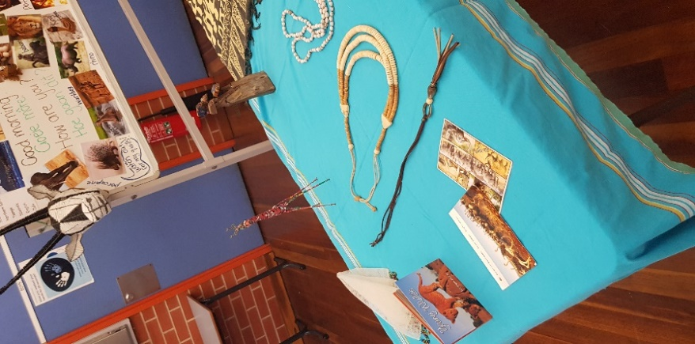
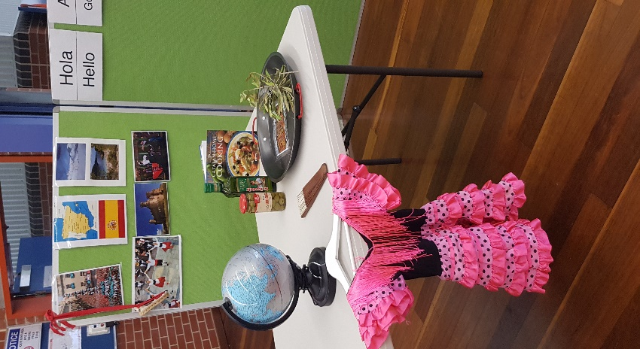

Message from the Catholic Scripture Teachers
We are providing families with this link for the Lent and Easter
Booklet: https://issuu.com/bbcatholic/docs/lent_and_easter_booklet_2_
Hope you all enjoy it.

Merit Awards Birthdays

Merit Awards
MERIT AWARDS

Chase | HB2 | Azailiah | HB12
Rachel | HB2 | Callie | HB10
Aayliyah | HB2 | Alekzander | HB12
Zeah | HB4 | Ivy-Lee | HB12
Mikayla | HB4 | Ivy | HB13
Haylee | HB4 | Korben | HB13
Dustin | HB4 | Koa | HB13
Bonnie | HB9 | Dyani | HB14
Ben | HB9 | Marshall | HB14
Mayella | HB9 | Piper | HB14
Varish | HB10 | Olivia | HB22
Olivia | HB10 | Cooper | HB22
Maddie | HB10 | Portia | HB22

Harrison | Mason
Liam | Logan
Isaac | Jasmine
Reuben | Mayella
Charlotte | Haylee
Kaiya | Abbey
Kooper | Adam
Katariina | Jonah
Amara | Varish

Canteen News
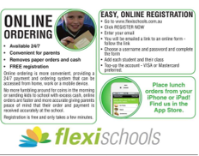

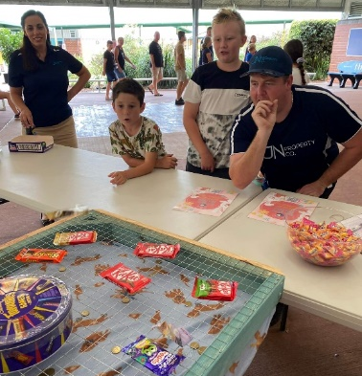
P & C News
Election BBQ
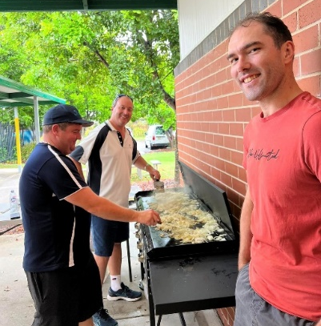
A huge thank you to our executive team and their husbands who held the election day barbecue on Saturday. It was lovely seeing the community out, even on such a horrible wet day. Thank you if you came out and helped support our school’s P&C by purchasing a sausage sandwich or bacon and egg roll!

A massive shout out to the Wyong Lions Club for sending us three amazing volunteers to help cook the BBQ. The 3 men who helped have over 120 years of volunteering experience in our local community between them. What great pillars of our community. Thank you so much for your help!
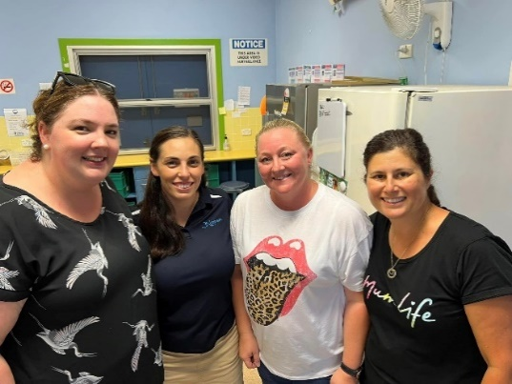
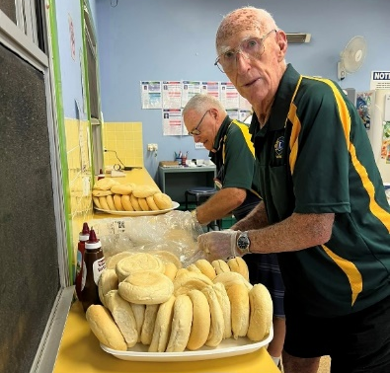
A huge thank you to Ken, our groundsman for helping with setting up and to Jacqui in the canteen for allowing the P&C to use the canteen. To Coastal Sand, Soil & Landscape Supplies, thank you for sponsoring our event.

A special shout out to the students that helped spruik our event to all the voters who came. They were collecting donations, helping with the guessing competition, helping in the canteen and generally being amazing representatives for Woongarrah Public School. Well done!

Easter Raffle
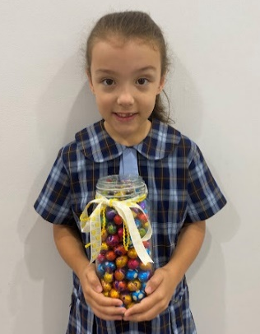
Hurry, our Easter raffle is closing soon! Make sure you purchase your tickets for your chance to win! First prize is $100 cash and an Easter surprise (total value $150). Raffle tickets can be purchased online here: https://rafflelink.com.au/easterrafflewps2023. Hurry the raffle closes this Sunday 2nd April. Feel free to share with your friends and family on your socials. Winners will be announced next week!

Easter Egg Guessing Competition
During our Election BBQ, the P&C ran an Easter Egg Guessing Competition. The lucky and very lovely winner Laira has generously donated her prize to the students of WPS! The P&C have organised with the SRC to hold a guessing competition with all the classes. Over the next week, the SRC will visit each class to guess, how many eggs are in the jar. The lucky class with the closest guess will win the jar to share amongst their class. Good Luck!

Special P&C Meeting
We are having a special meeting this Friday 31 March at 1:45pm at Cheryl's house (please contact the P&C directly for location address) to organise our Mother’s Day event. Anyone is welcome to join - we love having new voices and ideas!
Please follow us on Facebook: https://www.facebook.com/woongarrahpandc
Wishing you and your families a very safe and Happy Easter from all of us in the P&C. Looking forward to all the events we have planned for Term 2. Enjoy your school holidays!

Rebecca MacRae
Secretary

Dear Families of Year 6 Students,
Do you have a child finishing primary school this year? If an extra $500 would help you prepare for the costs of starting high school in 2024, then please read on to learn more about the free Saver Plus program.

Saver Plus is a matched savings and financial education program that matches participants’ savings dollar-for-dollar up to $500 for education costs such as uniforms, books, excursions, sports fees and laptops.
Participants save for a period of 10 months, so families who start now will be able to complete the program and receive their matched savings in February 2024.

Are you eligible?
You must meet all the eligibility criteria to take part in the program:
- Be 18+ years old
- Have a Health Care Card or Pensioner Concession Card
- Receive an eligible Centrelink payment (for example: Family Tax Benefit, Parenting Payment, Jobseeker, Child Care Subsidy, and many more)
- Have a child in school or be studying yourself
- Have regular income of at least $50/month (this could be yourself or your partner, from employment, Child Support, Carers Payment, or other informal income)
Over 1200 families in the Central Coast region have already benefitted from Saver Plus in the past 12 years, and all-around Australia we’ve reached 55,000 participants since the program began in 2003.
If you are interested in being rewarded for saving and believe you might be eligible for the program, please contact me and let’s get your Saver Plus journey started. Phone/text 0428 282 900, or email Leonie.Sykes@thesmithfamily.com.au.

I would be happy to help you on your savings journey. If you’re eligible, start now and we’ll help take the stress out of next year’s back to school. To find out more please call me, or to apply, go to www.saverplus.org.au or call 1300 610 355
I’m looking forward to speaking with you. Happy saving,

Warm regards,
Leonie Sykes
Saver Plus Coordinator
The Smith Family

