WOONGARRAH PUBLIC SCHOOL

63-73 Mataram Road, WOONGARRAH NSW 2259
ph: 43927493 fax: 43927807
email: woongarrah-p.school@det.nsw.edu.au
Website: woongarrah-p.schools.nsw.gov.au

The inclusive and caring school where expert staff support students to achieve excellence.

Thursday 6 April NEWSLETTER Term 1 Week 11

Annual Report 2022
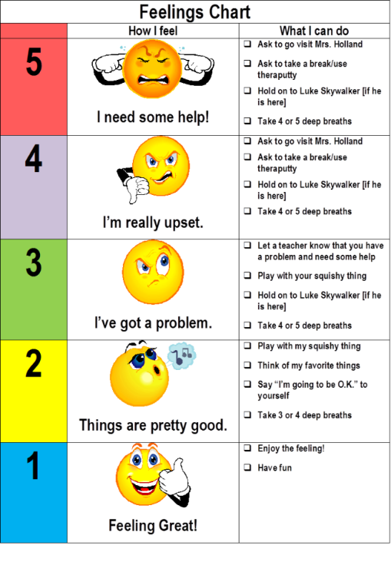
I am pleased to attach the annual school report for 2022 for your information. If you have any questions about the annual report, please contact me at Sharon.buhr@det.nsw.edu.au. More information about our Strategic directions and targets for 2023 will be in the Term 2 Newsletters.

Thank you.
This is my last Newsletter as relieving Principal as Mrs Clarkson will be returning as Principal in Term 2. Thank you to the students, staff and parents that have supported me in the relieving principal position, your support has been greatly appreciated. I look forward to returning to my Deputy Principal, Learning and Support Coordinator and Kindergarten supervisor roles in Term 2.

5-point scale
You may have heard your child say “I am at a 1” or “I am at a 3”. What does this mean? This year the students are being taught to self-regulate and understand their feelings. Each class is read a social story to understand their feelings and develop a 5-point scale. Students are taught that it is ok to sometimes feel anxious or frustrated but when they feel this way, they need to identify that they feel this way by telling the teacher “I feel like a 3 or my body is at a 3” and then take the action to get their bodies back to a 1, so they are feeling great and are ready to learn. A sample 5-point scale is attached for your information.
Happy Easter and holidays.
I would like to wish all our families a happy and safe Easter break and school holidays. Students return on Wednesday 26 April.

Relieving Principal
Mrs Sharon Buhr

ANZAC day march and service
Ms Miller will be leading a group of Woongarrah students for the ANZAC day march. Students are to meet Ms Miller 10 minutes before the march commences wearing full school uniform. Details are as follows:

Anzac March
Address: Ron Alt Ln, Toukley NSW, Australia
View on Google Maps
Time: 9:45 am
Date: Tuesday 25 April
Information: March proceeds along Canton Beach Road into Main Road and past the Cenotaph then into Athol Street and ending at the Cenotaph.

ANZAC Day School service
Ms Miller will lead the ANZAC day school service on Wednesday 26 April starting at 2pm.

Term 2 Dates

24 April – Staff Development Day
25 April – ANZAC Day public holiday
26 April – Students return to school.
26 April – School’s ANZAC Day service
5 May – Coral Festival Choir rehearsal at WPS
9 May – Paul Kelly cup – AFL
12 May – Cross Country carnival Woongarrah oval
12 May – P & C Mother’s Day event
15-19 May – Wellbeing week
17 May – Stage 1 Reptile Park Excursion
19 May – Zone Cross Country carnival
26 May – Sorry Day – 3-6 Assembly
29 May – 2 June – Reconciliation week
31 May- Stage 3 excursion
2 June – Jump Rope for Heart Skip off.
2 June - SRC Sports mufti to raise money for Stewart House
5 and 19 June – Review meetings
12-16 June – Wellbeing week
14 June – K-2 responsible pets incursion
28 June – NAIDOC day

Assembly Roster
Term 2

Week 2 - 3-6 Assembly | HB8 Hosting
Week 3 – K-2 Assembly | HB9 Hosting
Week 4 – 3-6 Assembly | HB4 Hosting
Week 5 - K-2 Assembly | HB11 Hosting
Week 6 - 3-6 Assembly | HB3 Hosting
Week 7 - K-2 Assembly | HB10 Hosting
Week 8 - 3-6 Assembly | HB2 Hosting
Week 9 - K-2 Assembly | HB5 Hosting
Week 10 – 3-6 Assembly | HB1 Hosting

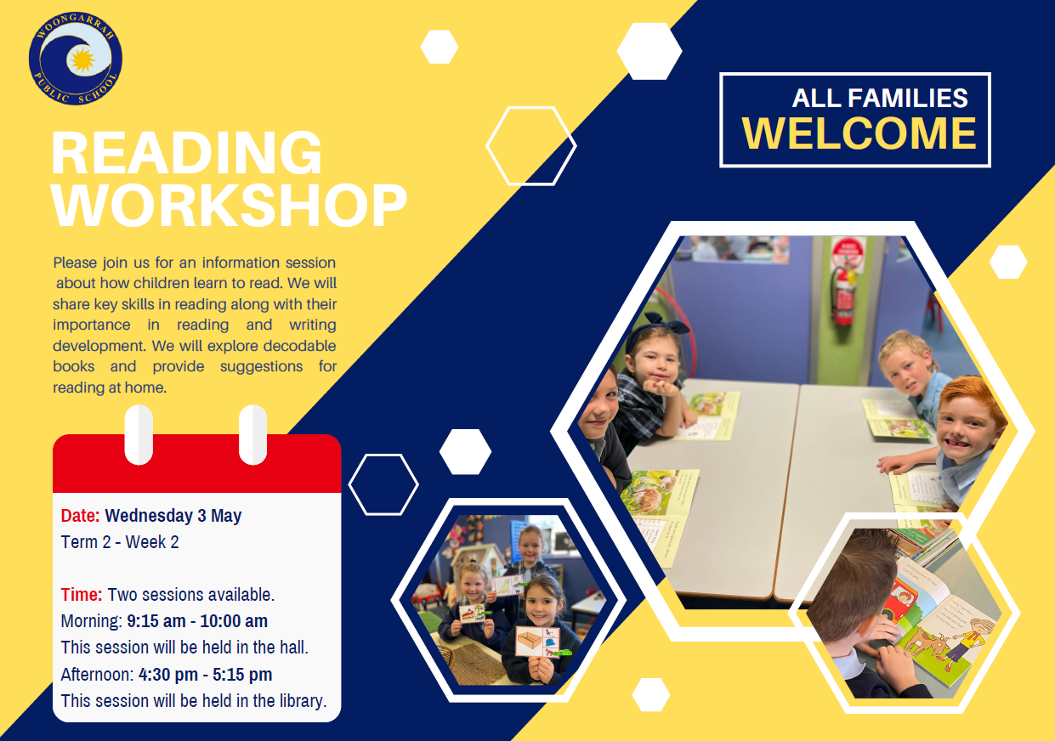

Kindergarten Term 1 in Review
Kindergarten Term 1 in Review
English
In English, students have been learning about phonemic awareness and phonics through the Heggerty and Little Learners Love Literacy Programs. You may have heard of Milo Monkey! Students have been learning letters (graphemes) and sounds (phonemes) and how to decode, segment and blend. Students have engaged with a range of high-quality texts including Starting School, We’re Going on a Bear Hunt, Edward the Emu and the Book with No Pictures. These wonderful texts are used to build oral language, vocabulary, reading and writing skills.
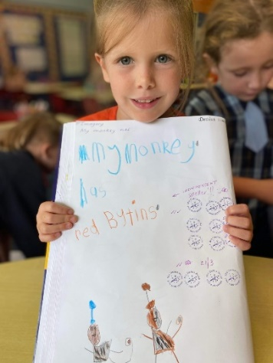

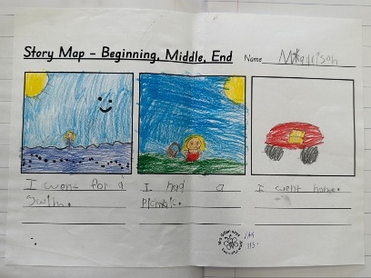
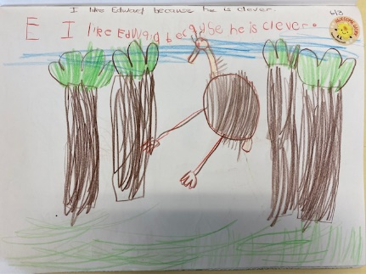
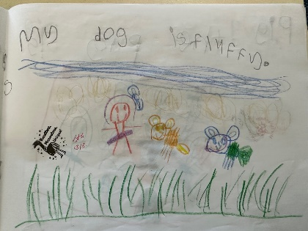

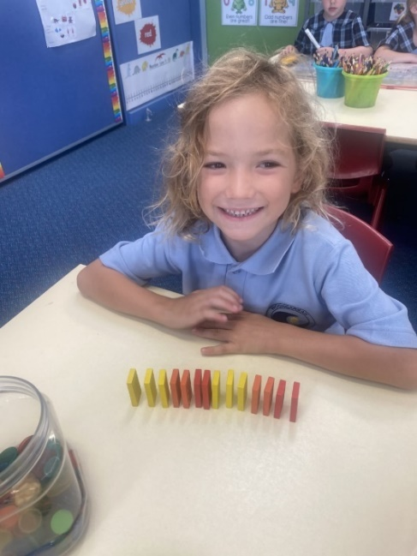
Mathematics
In mathematics, students have been learning to represent whole numbers, patterns combining and separating quantities, 2D shapes and 3D objects, data, forming groups, length, and mass. Students engage in daily Number Talks to build numbers sense, mental maths, and flexibility with numbers. In maths lessons students have been learning to read and write numbers, and to show, discuss and justify their mathematical ideas and solutions and connect maths to their everyday world.

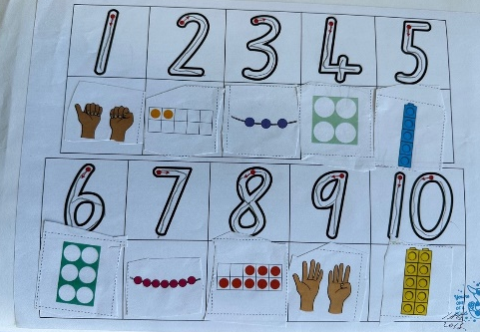
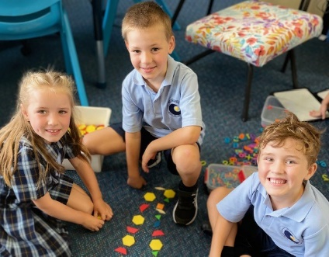

Geography
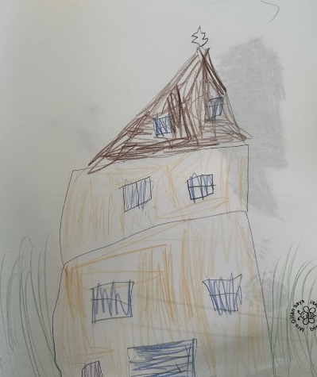
This term, students have learned that people live in places and that these places are important to them. They looked at how the location of places can be represented on maps. Students developed an understand of what makes a place special and that this might differ for different people.

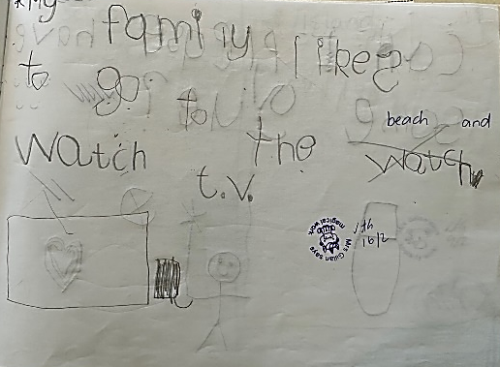

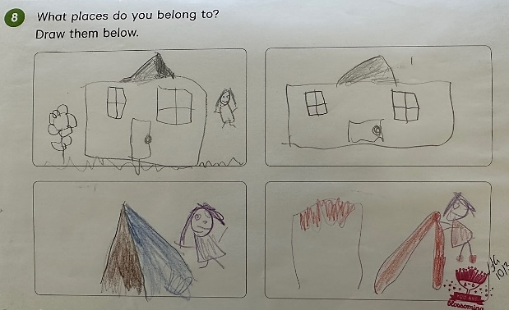

Music & Worry Woos
The students have been enjoying a wonderful music and PDHPE program each Tuesday with Mrs Dezius. In music, students have been singing songs, participating in movement activities, and listening and responding to music. During Worry Woo sessions, students have been learning to communicate, learning about emotions and how to communicate their feelings.

We have had a wonderful term of learning and look forward to an exciting Term 2.

Ms Miller, Mrs Johnson, Mrs Cranstone and Mrs Gillan

Stage One Newsletter- Term 1 in Review

Students have settled into their 2023 classes and have been working hard. All students have been taught the Woongarrah Way and the Anti Bullying program. Students have been well behaved in the classroom and playground, which is evident in the number of students achieving their Bronze Awards this term.

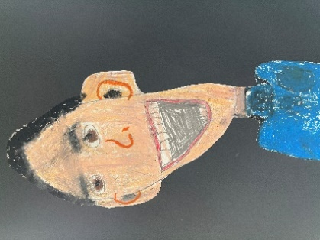
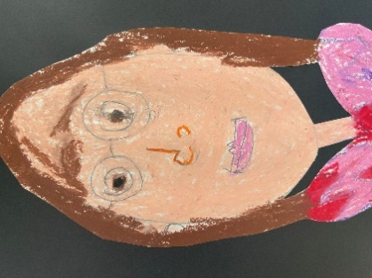
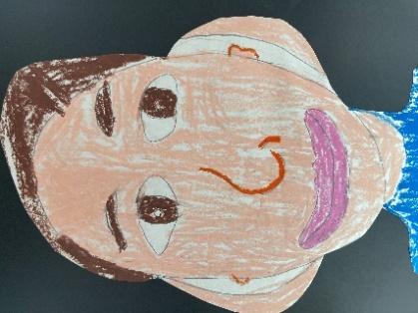
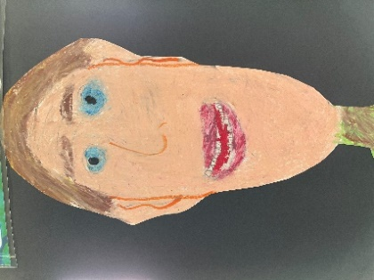

Self portraits

Both the Year 1 and Year 2 classes have been working hard on the new Department of Education units of work in English and mathematics. Year 2 students recently studied the book “Sophie Scott goes South” by Alison Lester. Students researched an ice breaker and labelled the ships parts. They looked at Australia’s involvement in the Antarctic and researched information on a penguin. Students also created a timeline of Sophie Scott’s time in the Antarctic.

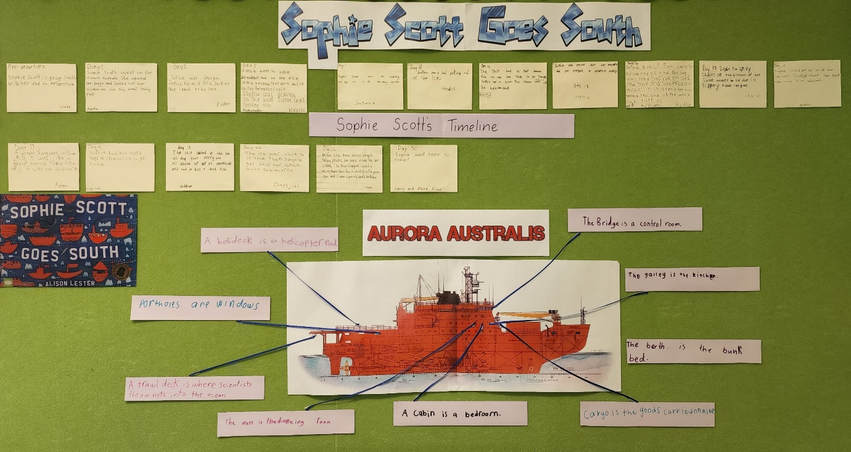
HB12 Sophie Scott goes south display.

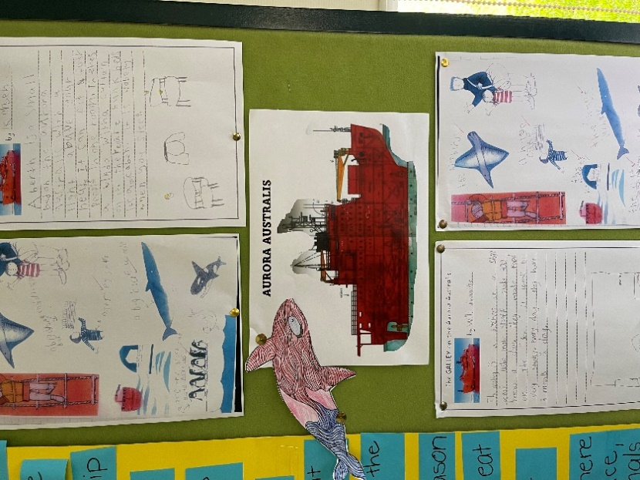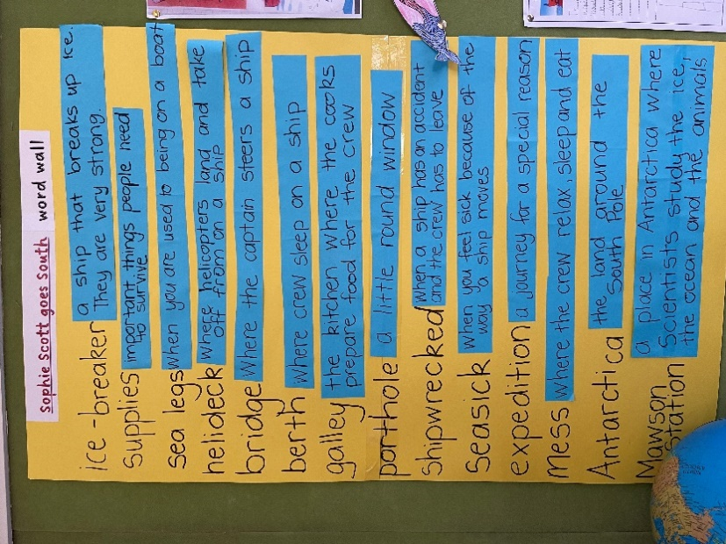

HB13 display and research.
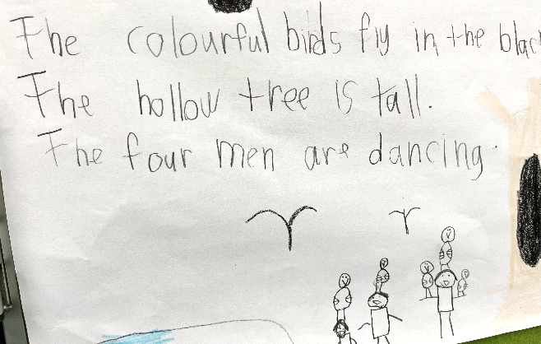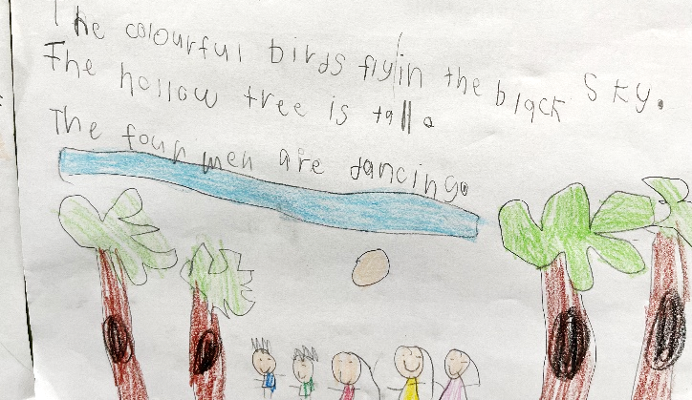

HB14 writing using adjectives.

The year 1 focus has been on building sentence structure through looking at a variety of texts and following the author’s structure. It has been wonderful to see the development of the student’s writing ability since the start of the year.

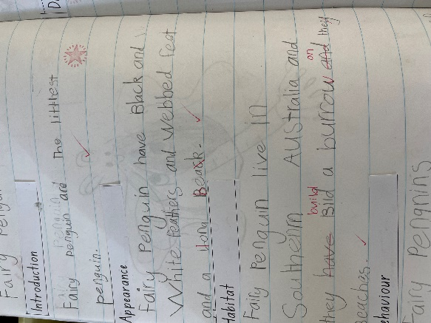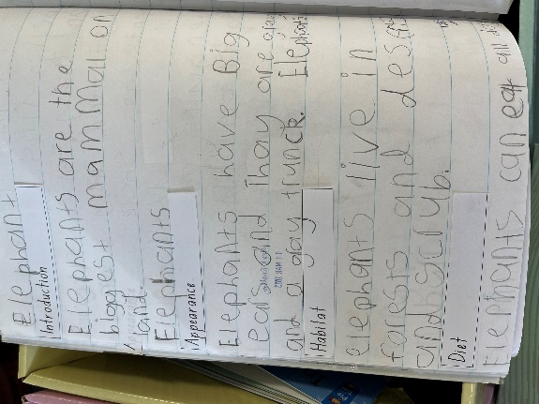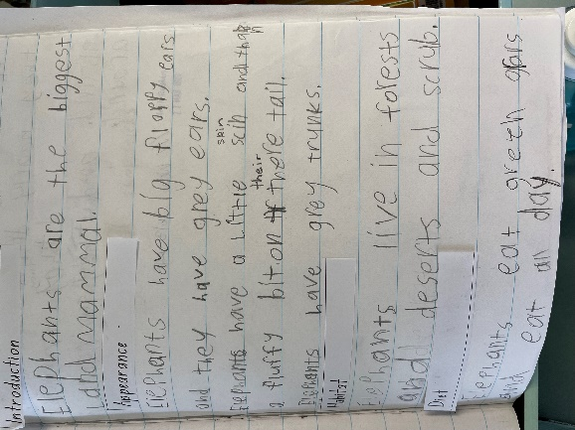
Information reports-year 1
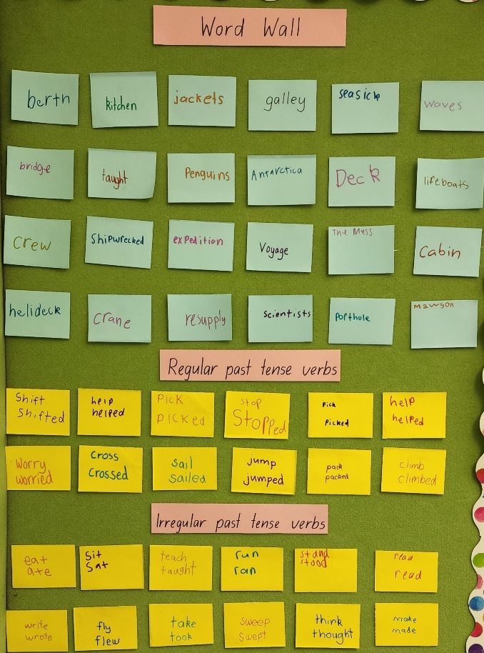
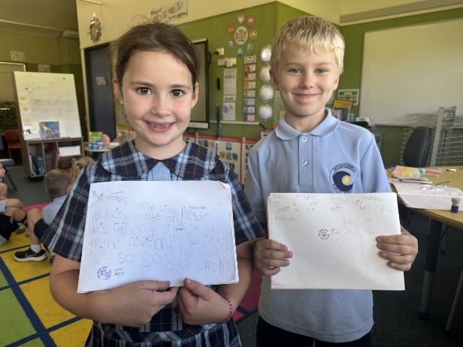

Year 1 writing wall and writing tasks.

The new mathematic units of work are all about building a deeper knowledge of mathematics and how to think through problems. Students are enjoying exploring different numbers and learning to look for patterns. With daily number talks, students are learning to discuss their thoughts and developing more efficient thinking strategies through listening to their peers.
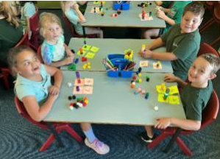
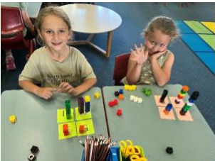

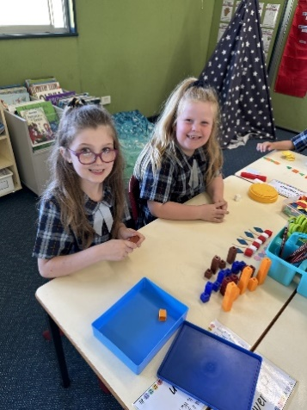
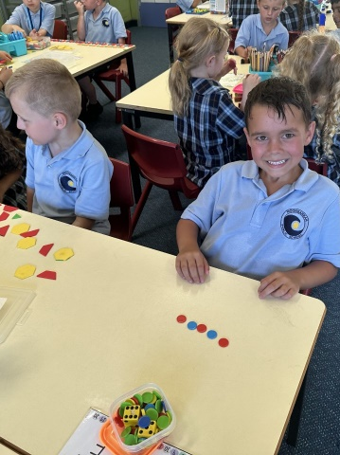
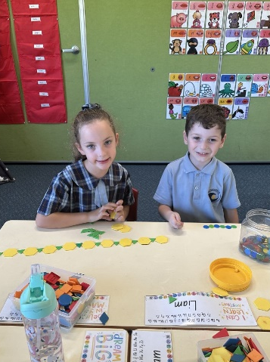

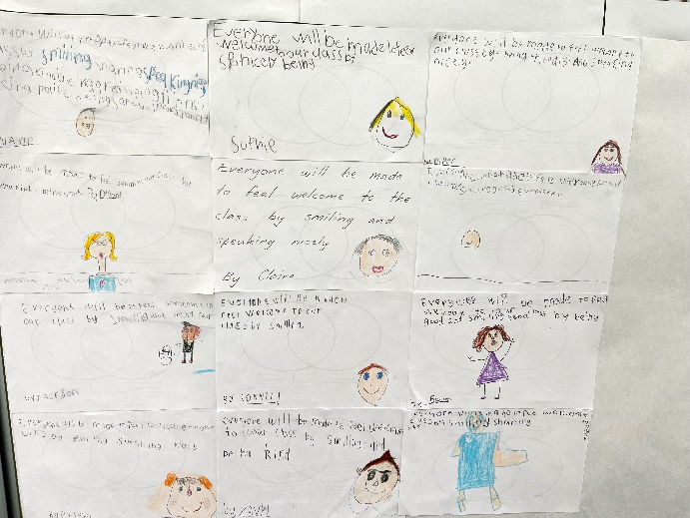

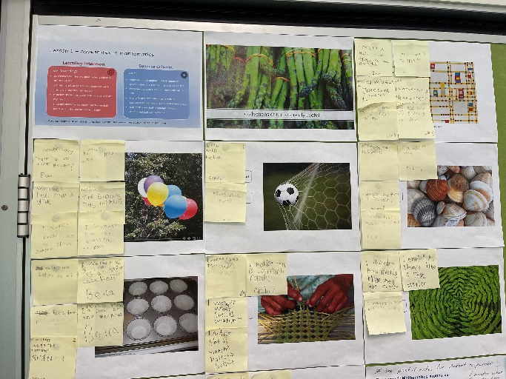

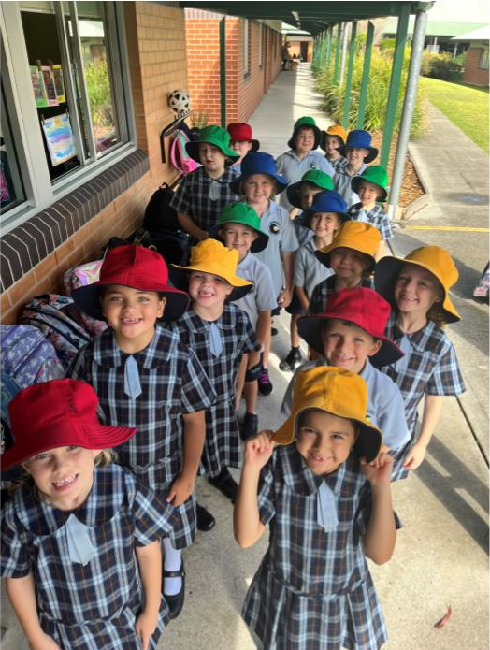
The new hats have been a fantastic addition to the school uniform. It looks fantastic on Fridays to see the students all in their house colours, it also makes it very easy for the students to remember their houses!

Australian Reptile Park Excursion
On Wednesday 17 May, all stage 1 students will be going to the Australian Reptile Park. The cost of the excursion is being covered by the school; however, we do require permission notes to be signed and returned to the school.
It has been a very busy and productive term for all classes.

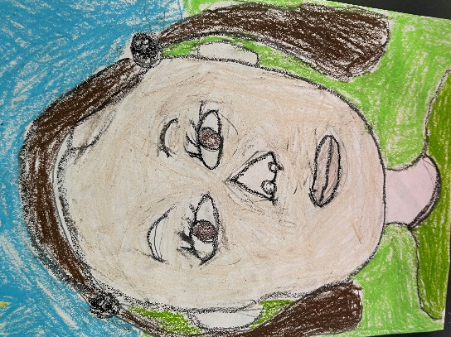
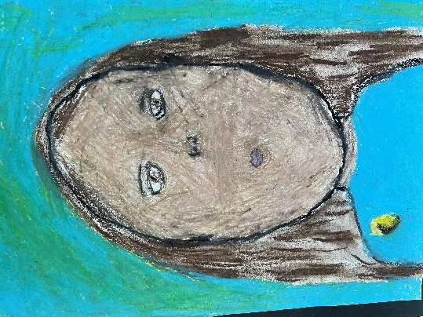
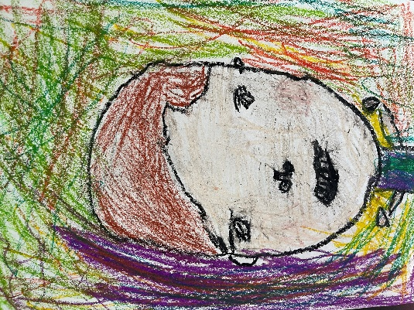

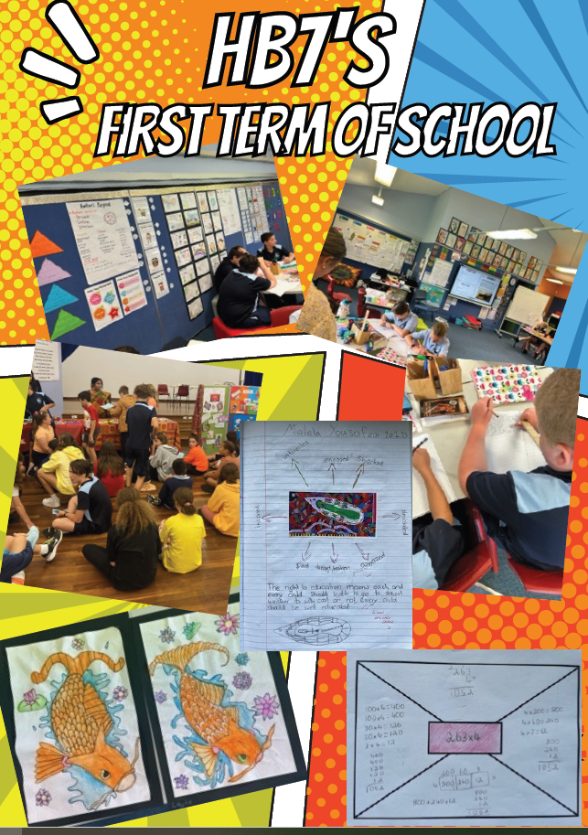
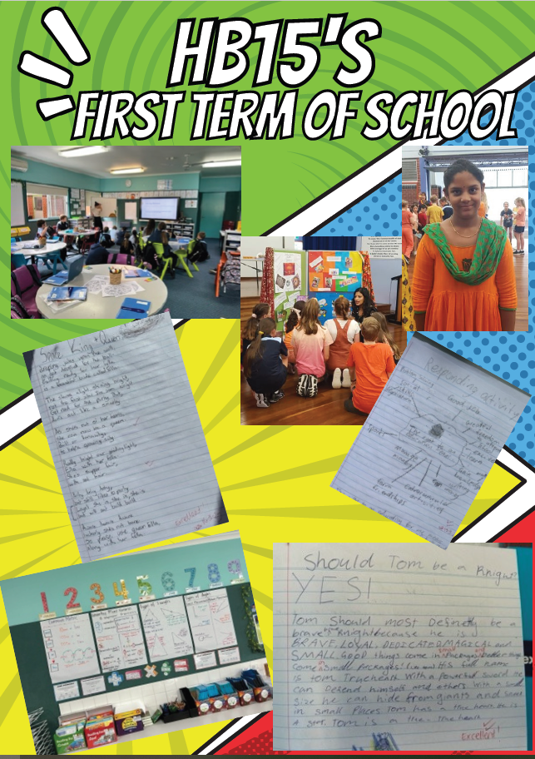

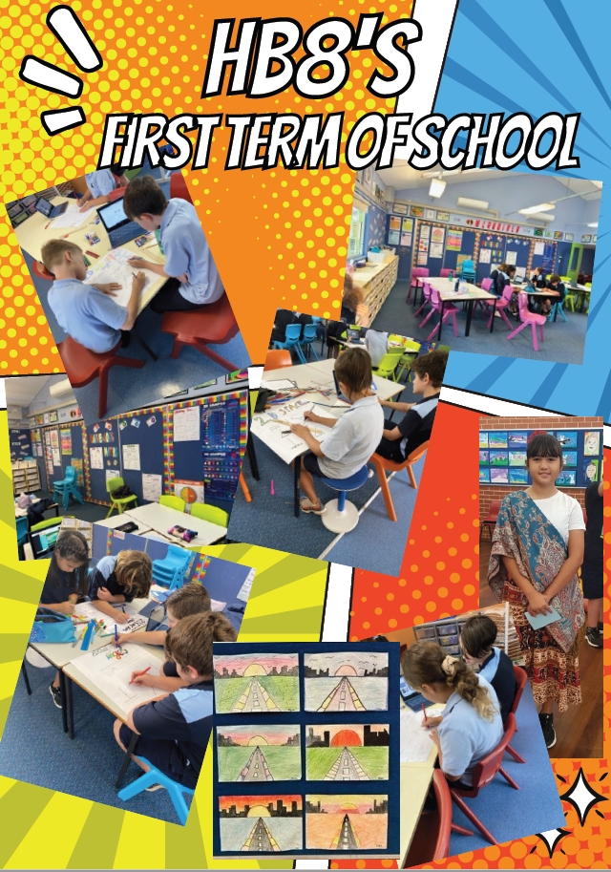

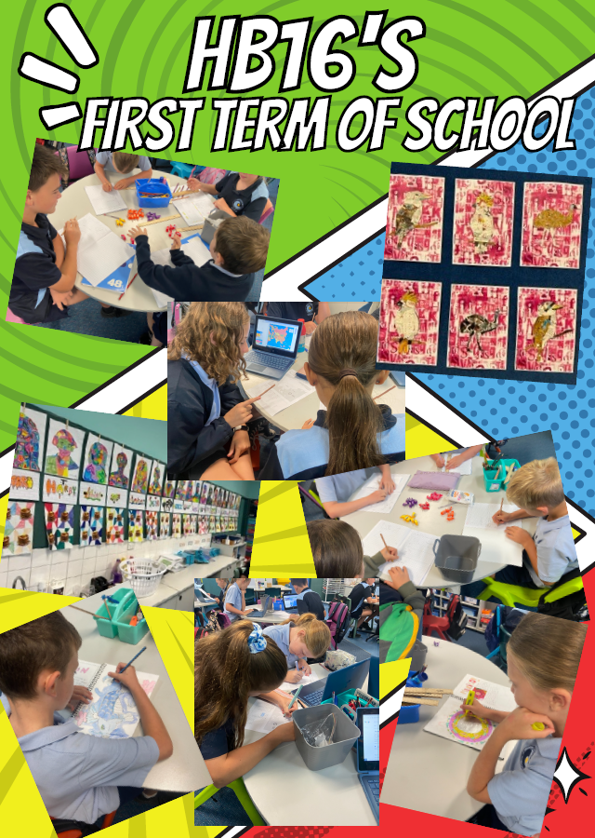

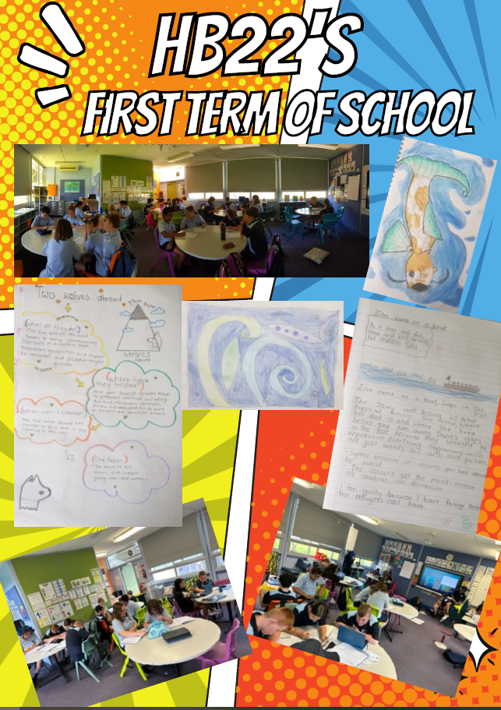

P&C News
Woongarrah Public School P&C are excited to announce that we will be putting on our very first Mothers Day Event! Please join us for an afternoon of refreshments, music, lucky door prizes and photo opportunities on Friday 12th May, 3.15pm - 4.00pm, under the COLA.
Tickets are $5.00 per adult and free for Woongarrah Public School students. Please click the link to RSVP for our event:
https://checkout.square.site/.../QSWXE65TWMP3ISCCINOSFK2B

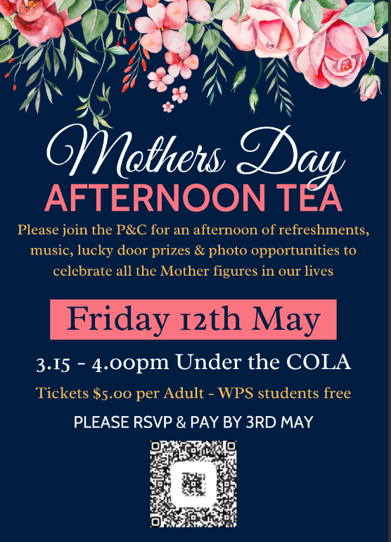
Tickets are on sale until the 3rd May. This is a catered event, therefore late ticket purchases cannot be accepted.

We are so very excited! We have Wyong Lions volunteers coming to assist, so all Mums can have a break. If you have a family member who wants to assist on the day we always can do with more volunteers, so please reach out via our Facebook page or email.

Looking forward to what will be a special afternoon celebrating all the mother figures in our lives
Kind regards,
WPS P&C

