**WOONGARRAH PUBLIC SCHOOL**

63-73 Mataram Road, WOONGARRAH NSW 2259

ph: 43927493 fax: 43927807

email: [woongarrah-p.school@det.nsw.edu.au](mailto:woongarrah-p.school@det.nsw.edu.au)

Website: [woongarrah-p.schools.nsw.gov.au](http://www.woongarrah-p.schools.nsw.edu.au)

The inclusive and caring school where expert staff support students to achieve excellence.

**Thursday 4 May NEWSLETTER Term 2 Week 2**

**From the Principal:**

It’s great to be back at Woongarrah and I have really enjoyed catching up with the many, many great things that happen in a school in a term. You can see from the term 2 calendar below that we have so much more ahead of us! Can I extend my thanks to Mrs Buhr for her work as Relieving Principal and to the wonderful staff who supported her during my long service leave.

It was good to meet with the P&C last week for the April meeting. Our dedicated P&C are always busy planning events and activities for our students and families and there is much to look forward to, starting with the Mother’s Day afternoon tea next week. I extend my congratulations and thanks to all involved and to our P&C executive for 2023.

President: Michelle Gatt

Vice President: Natalie Smith

Vice President: Norma Lyden

Secretary: Rebecca MacRae

Treasurer: Cheryl Lean

Two improvement priorities for this term are student attendance and the use of the Parent Portal on Sentral for communication. Mrs Sharp, our Business Manager, has included useful information about the latter in this newsletter, with more to follow over coming weeks. For attendance, we are introducing new rewards for students who are attending 95% or more of the time, as this is the expected attendance rate for students. Watch this space!

**Attendance**

**Attendance Matters**

When your child attends school every day, learning becomes easier, and your child will build and maintain friendships with other children.

Parents and carers can help foster positive attendance habits by:

* helping their child learn the importance of punctuality and routine.
* ensuring their child arrives on time from the start of the school day, ready to participate in learning.
* reducing disruption to learning where possible, by planning any necessary appointments outside of school time
* promptly communicating any absence to the school (within 7 days of the first day of any absence)
* working with the school to encourage and support regular attendance.

**100% Attendance Term 1**

Congratulations to the following students for 100% attendance in Term 1.

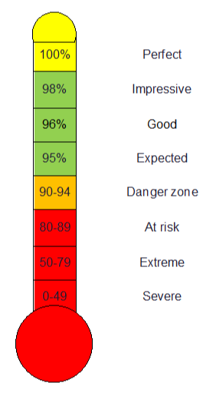

**CONGRATULATIONS**

|  |  |  |  |  |
| --- | --- | --- | --- | --- |
| **Kindergarten** | |  | **Year 3** | |
| Georgie | HB10 |  | Ethan | HB1 |
| Kora | HB10 |  | Ona | HB1 |
| Jordi | HB10 |  | Keira | HB1 |
| Callie | HB10 |  | Ivy | HB2 |
| Sloane | HB5 |  | Owen | HB2 |
| Aurora | HB5 |  | Lovell | HB2 |
| Benjamin | HB5 |  | Cooper | HB2 |
| Kooper | HB5 |  | Jamie | HB3 |
| Tyler | HB5 |  | Logan | HB4 |
| Alexander-Fox | HB6 |  | Sebastian | HB4 |
| Harper | HB6 |  | Kathleen | HB4 |
| Jensen | HB6 |  | Abbey | HB4 |
| Lexi | HB6 |  | **Year 4** | |
| Madeline | HB6 |  | Isabella | HB1 |
| Karlee | HB6 |  | Aurey | HB2 |
|  |  |  | Hank | HB2 |
| **Year 1** | |  | Rachel | HB2 |
| Maddison | HB10 |  | Cooper | HB2 |
| William | HB10 |  | Conor | HB3 |
| Pippa | HB10 |  | Lukas | HB3 |
| Oliver | HB10 |  | Mia-Rose | HB4 |
| Imogen | HB11 |  | Dustin | HB4 |
| Edwin | HB11 |  | Kyza | HB4 |
| Ruby | HB11 |  | **Year 5** | |
| Olivia | HB9 |  | Nicholas | HB15 |
| Hallie | HB9 |  | Aswathi | HB15 |
| Mayella | HB9 |  | Tyler | HB16 |
| **Year 2** | |  | Chloe | HB7 |
| Andrew | HB12 |  | Morgan | HB7 |
| Clara | HB12 |  | Georgia | HB8 |
| Addisyn | HB12 |  | Alyssa | HB8 |
| Harry | HB12 |  | Lexi | HB8 |
| Lakeesha | HB13 |  |  |  |
| Penelope | HB13 |  | **Year 6** | |
| Tatum | HB13 |  | Jake | HB16 |
| Jax | HB14 |  | Sienna | HB16 |
| Bella | HB14 |  | Nate | HB16 |
| Ruby | HB13 |  | Ella-Jaye | HB22 |
|  |  |  | Juliette | HB7 |
|  |  |  | Paige | HB7 |

[NSW Police Legacy Child Safety Handbook – New Issue:](https://nswppa.schoolzineplus.com/newsletter/article/684?skin=1)

**Upcoming Events**

The 2023 Issue of the NSW Police Legacy Child Safety Handbook is available. The **“NSW Police Legacy Child Safety Handbook”** is a comprehensive and free resource to assist parents, carers as well as teachers on a range of topics essential to child safety. The updated digital edition (link below) also includes important content updates from: NSW Rural Fire, NSW Ministry of Health, NSW Police Force, Fire and Rescue NSW, Transport NSW, State Emergency Services, NSW Department of Family & Community Services, eSafety Commissioner and NSW Office of the Children's Guardian.

**Term 2 Dates**

5 May – Choir rehearsal

9 May – Paul Kelly cup – AFL

10 May – Evacuation Drill

12 May – Cross Country carnival

12 May – P & C Mother’s Day event

15 -25 May – Year 4, 6 Check in Assessments

15-19 May – Wellbeing week

17 May – PSSA Girls soccer

17 May - Stage 1 Reptile Park Excursion

18 May – PSSA Boys soccer

19 May – SRC Sports mufti to raise money for Stewart House

19 May – Zone Cross Country

17 May - Stage 1 Reptile Park Excursion

18 May – PSSA Boys soccer

19 May – SRC Sports mufti to raise money for Stewart House

19 May – Zone Cross Country

22 May - AECG Meeting at Warnervale PS

24 May – National Simultaneous Storytime Day

25 May – Dance group rehearsal

26 May – Sorry Day – Years 3-6 Assembly

29 May – 2 June – Reconciliation week

31 May- Stage 3 excursion

2 June – Jump Rope for Heart Jump off.

2 June – Mufti Day – gold coin donation

5 June – Review meetings

12 June – Wellbeing week

14 June – K-2 Responsible Pets incursion

19 June – Review meetings

27 June – NAIDOC day

Please click on the below link to view the updated digital handbook:

[Click here to view the Digital Handbook](https://issuu.com/associatedmediagroup/docs/cshb_summer_2022_23_single_pages?fr=sMzY1ODUzMzA2OTM)







You can view your child’s attendance in the Sentral Parent App.

Tap the Student Photo

Tap the + Attendance icon

The Percentages are shown

Tap View attendance summary to reveal Attendance Grid

**Grid Legend**

|  |  |
| --- | --- |
| **LITERACY AND NUMERACY @ WPS** | |
| **Graphical user interface  Description automatically generatedGood readers have a rich vocabulary.**  Vocabulary refers to the words children need to know to understand what they hear and read, and to communicate. Vocabulary is the most powerful predictor of reading comprehension. Knowing what words mean is essential if your child is to understand what they have read. It also supports reading fluency.  Our stage 2 students have been reading quality literature filled with rich vocabulary. Take a look at some of the learning that has been taking place! | |
| *HB1 unpack new words in their “vocabulary suitcase”.* |   *HB2 refer to the vocabulary wall during their writing sessions.* |
| *HB3 use their interactive VCOP display to “spice up their writing”.* | *HB4 learn about the rich vocabulary in quality literature that they read as a class.* |
| **Activities to develop vocabulary at home.**  Adults play a significant role in the development of a child’s vocabulary. Through **everyday conversation** and by **reading to children**, parents and caregivers can introduce a variety of new words.    When introducing new words to your child, keep the following hints in mind:  First, provide a simple, child-friendly definition for the new word: “Enormous means that something is really, really big.”   * Second, provide a simple, child-friendly example that makes sense within their daily life: “Remember that really big watermelon we got at the fruit shop? That was an enormous watermelon!” * Third, encourage your child to give their own example: “What enormous thing can you think of? Can you think of something really big that you saw today? That's right! The bulldozer near the park was enormous! Those tyres were huge.” * Lastly, keep your new words active within your house. Over the following days and weeks, use each new vocabulary word in conversation. | |



**Jump Rope for Heart has kicked off at Woongarrah Public School**

Jump Rope for Heart is the Heart Foundation’s primary school skipping challenge that helps kids move more, have fun, and raise funds for lifesaving research and programs.

We’ve got an audacious goal to see our student Heart Heroes at **Woongarrah Public School** to log 40 hours of skipping throughout the program!  
  
[**Register your child online**](http://www.jumprope.org.au/parents), so they can receive the full benefits of the program and participate in online fundraising, simply follow the link below to get started. [www.jumprope.org.au/parents](http://www.jumprope.org.au/parents)

Students will be skipping during their allocatedsport time, to help raise money for this great cause.

We will hold our school Jump Off Day on Friday 2nd June (week 6), this will mark the end of the program and is a chance for everyone to come together to skip and show off their newly learned skills.

So, get your child registered so they can begin raising money and encourage them to practice their new learnt skills as well!

Thank you for supporting the Jump Rope for Heart program and Woongarrah Public School!

**From The Office:**

The Office have experienced many changes across the last 12 months with staff, systems, processes, and procedures. Our Office staff have changed on many occasions over this period due to staff leave and deployment which has been challenging in regard to training of numerous staff across positions. Everyone that has worked in the office have been amazing learning our procedures, team sharing and playing a strong role in learning, improving, and reviewing our systems and processes. This term we are lucky enough to secure Rebecca Kain, Angela Pascoe, and Nicole Patterson for another term in our relieving positions.

Our Team is keen to streamline our processes into one system which is Sentral. Our goal is for our parents to be able to use one source of communication for attendance, messages, newsletters, notes, and finance. This will be through your Sentral Parent Portal App. In time as we all experience and feel comfortable in using the Parent Portal App, we will be able to phase out using emails, Skoolbag and paper copies to communicate with our families.

We invite you all to be part of this journey. We are adding a section in the newsletter each fortnight that will update you on our progress, give hints and information on how to use the Parental Portal to its full capacity. As you may appreciate, this is going to be a learning curve for all of us and there will be times when some of the modules shared may not be perfect. We will ask you to contact us if you experience any problems and we will investigate to address and improve the modules to suit our school’s individual needs. Sentral may not offer a form or document in the same format as we are used to, but we will develop templates that are workable and meet the Departments Policies and Standards.

We have been entering our Attendance in Sentral since Term 3 2020. This module allows us to upload medical certificates, sign in late and early leavers, track unexplained attendance and see all student’s percentage of attendance easily. In our Sentral System we have set up an automatic email that is sent out to you every afternoon if your child is absent. This system is only as good as email addresses being correct. Many of us change our email addresses and this requires correct data entry across 2 systems at the moment. As more and more of you become comfortable with the Parent Portal App, we will reset that process so that you will get a notification in the app instead of by email allowing for a more efficient and correct record of attendance.

Our first step in streamlining our systems will be in Attendance. We have been getting quite a few absence explanations through Sentral and this term will begin trialling the Parent Portal to send home notifications in the app. You will receive a duplication in Term 2 of an email and a portal notification asking you to explain your child’s absence. You will be able to choose to use the portal to respond or reply by email. In Term 3 we are looking at moving to the portal notifications only and the email will be phased out.

We hope you all will come on the journey with us as we begin our newsletter section ‘From the Office’ as we convert to an innovated administration system to match the wonderful education our students receive at Woongarrah Public School.

Currently we send out an email for unexplained notices at the end of each day and ring home if there is an absence for 3 consecutive days. This term we will include any unexplained absences from the week in the daily email or portal notification that is sent home on Fridays. This will act as a reminder that we still haven’t received an explanation from outstanding unexplained absences for the current week.

We would like to introduce the Attendance Module in Sentral this week. For those who feel comfortable enough to have a go, please see the following information to submit your absences for your children through the Sentral Portal App.

**Sentral - Absences**

1. Log on to your Parent Portal App on your phone.

2. Select your Absences Icon – The red notification is because you have an unexplained absence after a roll has been marked.



3. Click on Explain Absence -

4. Type in Explanation and Submit

If you want to explain an absence in advance, you will not have a red notification.

1. Click on the Absences icon



1. Click the plus button

1. Select your child fill in the reason and date and any comments.
2. Push Send
3. We will receive your explained notice in our Sentral system and will process your notification before we send out the daily email or Sentral push notification.

**Just a reminder**

Permission notes to be returned for:

**Reptile Park Excursion**

**Cross Country Carnival**

**Central Coast Dance Festival**

**Sentral - Extended Leave Form (for Travel Requests)**

The Extended Leave Form can now be accessed through the Parent Portal App.

1. Log on to your Parent Portal App on your phone.



1. Graphical user interface, application

   Description automatically generated Select the Resources icon

3. Select Attendance Forms Folder

Select the Extended Leave Form

5. Hold your finger on the Download the Form and it should open in your browser. Download the form and save.

Fill out your form and save as Extended Leave Form Student Name.

Email your form to the school email account [Woongarrah-p.school@det.nsw.edu.au](mailto:Woongarrah-p.school@det.nsw.edu.au)

**Assemblies K-2 Birthdays**

|  |  |  |  |
| --- | --- | --- | --- |
| **Week** | **Day** | **Year** | **Hosting** |
| 2 | Thursday | 3-6 | HB8 |
| 3 | Friday | K-2 | HB9 |
| 4 | Thursday | 3-6 | HB4 |
| 5 | Friday | K-2 | HB11 |
| 6 | Friday | 3-6 | HB3 |
| 7 | Friday | K-2 | HB10 |
| 8 | Friday | 3-6 | HB2 |
| 9 | Friday | K-2 | HB5 |
| 10 | Friday | 3-6 | HB1 |



|  |  |
| --- | --- |
| Lillian | Sophie |
| Bridie | Noah |
| Sloane | Arielle |
| Quentin | Tyler |
| Zavier | Brayson |
| Talan | Noah |
| Benjamin | Adalyn |

**Canteen News**

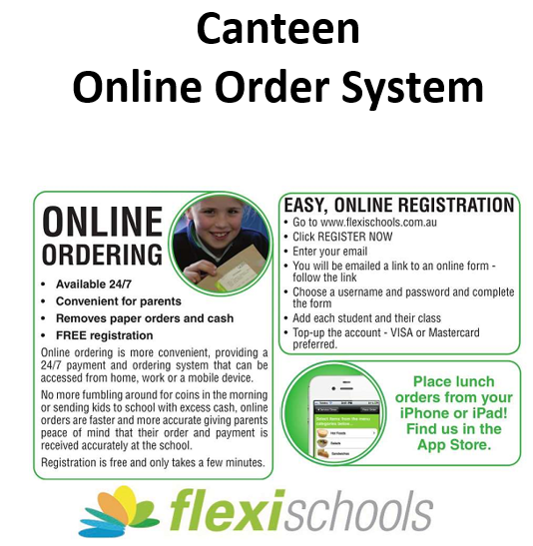



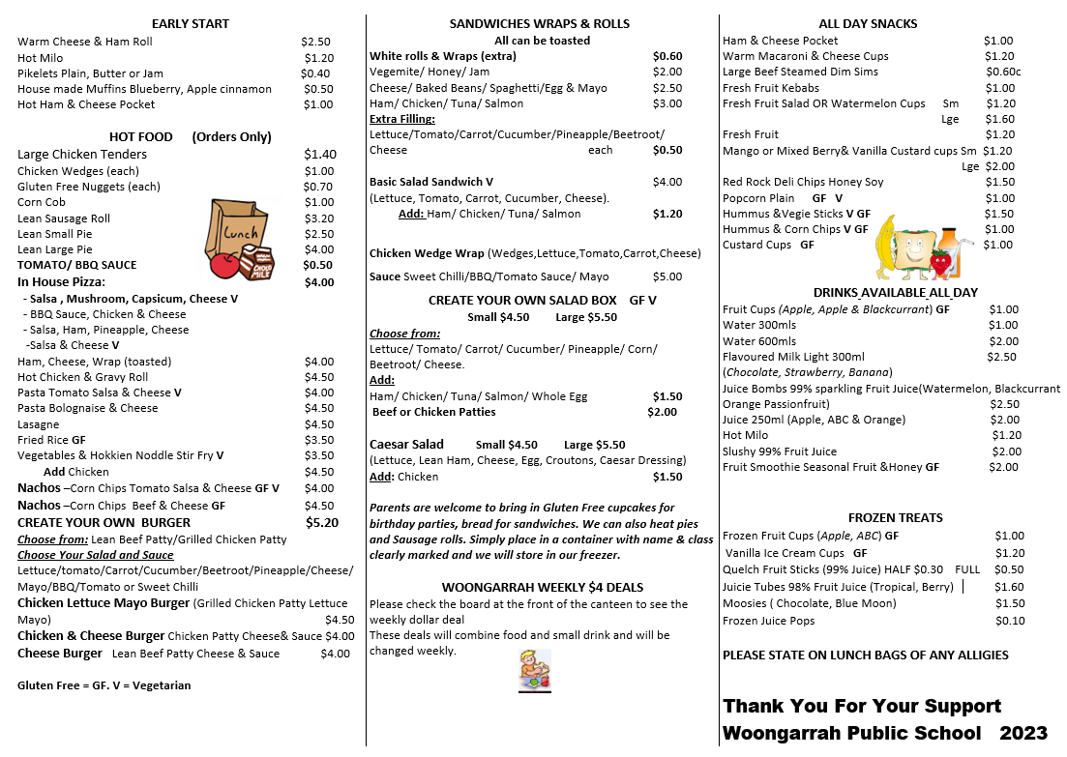

**Music Bus Lessons**

The Music Bus is running weekly lessons at our school in Term 2

Classes offered are:

* Keyboard (prep/kindy-y6)
* Ukulele  (prep/kindy -y6)
* Drums (y1-y6)
* Guitar (Y2-y6)

Lessons are:

* 30-minute duration - once per week.
* To be held in the hi-tech music classroom on wheels on our site.
* Cost $20 per week ($22 drums) payable by the term on commencement.

If you wish to take part in Term 2 please complete this expression of interest form asap

[https://app.smartsheet.com/b/form/ee4627a5204c46158e1ab17e7c8069c6](https://aus01.safelinks.protection.outlook.com/?url=https%3A%2F%2Fapp.smartsheet.com%2Fb%2Fform%2Fee4627a5204c46158e1ab17e7c8069c6&data=05%7C01%7CAngela.Pascoe1%40det.nsw.edu.au%7C85238b20d4cb41050c5708db49f71bcb%7C05a0e69a418a47c19c259387261bf991%7C0%7C0%7C638185097888431472%7CUnknown%7CTWFpbGZsb3d8eyJWIjoiMC4wLjAwMDAiLCJQIjoiV2luMzIiLCJBTiI6Ik1haWwiLCJXVCI6Mn0%3D%7C3000%7C%7C%7C&sdata=b1ZKo1nuinEm4Rw2pnIKdSQglKHgZBCAfwfrwPtVDKg%3D&reserved=0)